1.Image read, write and save operation

image_loader.py

import cv2 *#openCV use as cv2 in python  
  
#Loads a color image. Any transparency of image will be neglected. It is the default flag.  
#this function is used to read the image from location*img1 = cv2.imread('C:\\Users\\Vishal\\PycharmProjects\\pythonProject\\Image Processing\\Data\\boat.jpg',1)  
img1 = cv2.resize(img1,(1280,700))*#width ,height*print(img1)  
cv2.imshow("original",img1) *#It accept two parameters 1)- Name of screen ,2) - Image*cv2.waitKey(0) *#here parameter inside waitkey handle the life duration of an image*cv2.destroyAllWindows()

Output

original

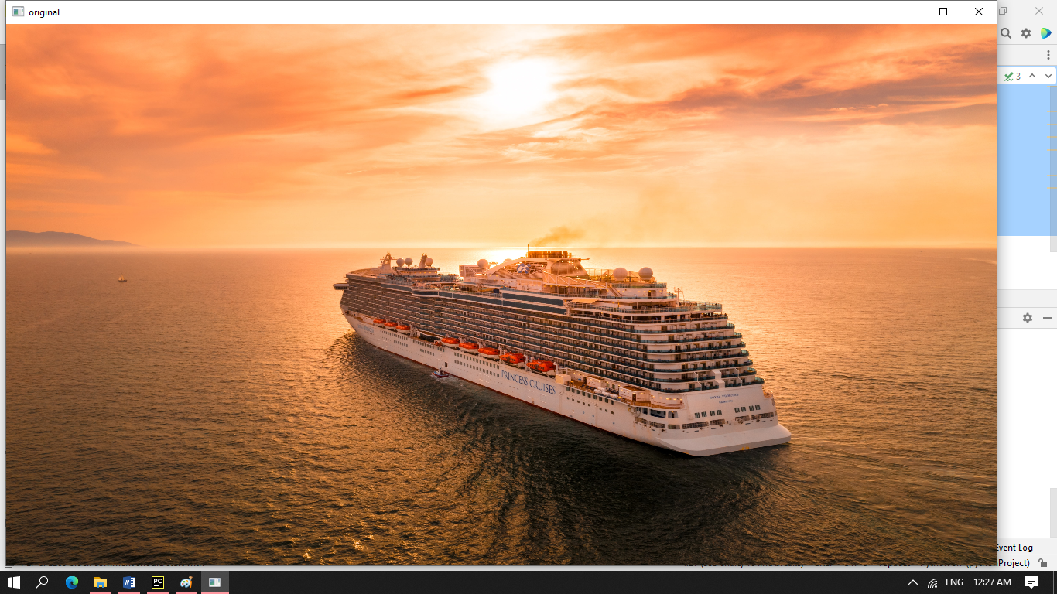

grayscale.py

import cv2 *#openCV use as cv2 in python  
  
#Loads a color image. Any transparency of image will be neglected. It is the default flag.  
#this function is used to read the image from location*img1 = cv2.imread('C:\\Users\\Vishal\\PycharmProjects\\pythonProject\\Image Processing\\Data\\boat.jpg',1)  
img1 = cv2.resize(img1,(1280,700))*#width ,height*print(img1)  
cv2.imshow("original",img1) *#It accept two parameters 1)- Name of screen ,2) - Image  
  
#cv2.IMREAD_GRAYSCALE : Loads image in grayscale mode*img2 = cv2.imread('C:\\Users\\Vishal\\PycharmProjects\\pythonProject\\Image Processing\\Data\\boat.jpg',0)  
img2 = cv2.resize(img2,(1280,700))*#width ,height*cv2.imshow("Gray Scale Image",img2)  
print("Image in gray scale==\n",img2)  
  
cv2.waitKey()  
cv2.destroyAllWindows()

Output

original

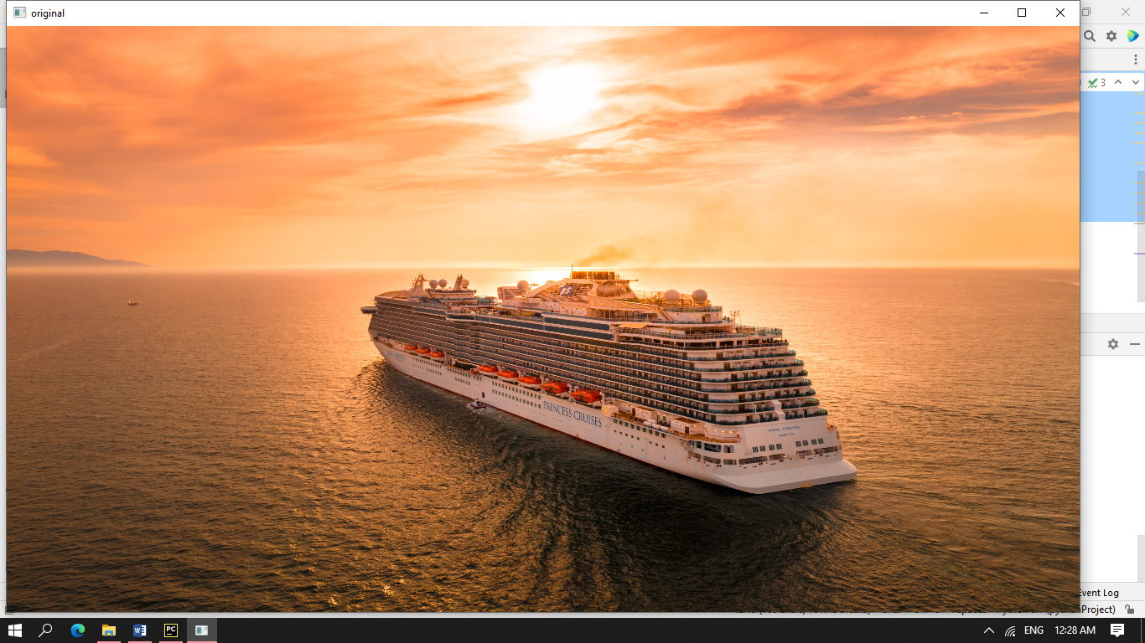

Gray Scale Image

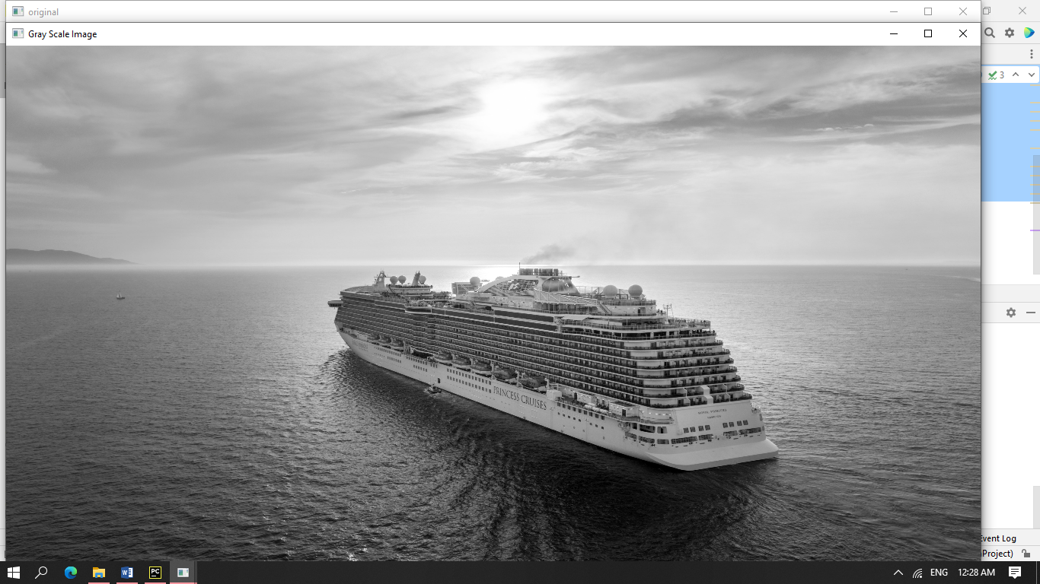

unchanged.py

import cv2 *#openCV use as cv2 in python  
  
#Loads a color image. Any transparency of image will be neglected. It is the default flag.  
#this function is used to read the image from location*img1 = cv2.imread('C:\\Users\\Vishal\\PycharmProjects\\pythonProject\\Image Processing\\Data\\boat.jpg',1)  
img1 = cv2.resize(img1,(1280,700))*#width ,height*print(img1)  
cv2.imshow("original",img1) *#It accept two parameters 1)- Name of screen ,2) - Image  
  
#cv2.IMREAD_GRAYSCALE : Loads image in grayscale mode*img2 = cv2.imread('C:\\Users\\Vishal\\PycharmProjects\\pythonProject\\Image Processing\\Data\\boat.jpg',0)  
img2 = cv2.resize(img2,(1280,700))*#width ,height*cv2.imshow("Gray Scale Image",img2)  
print("Image in gray scale==\n",img2)

*#cv2.IMREAD_UNCHANGED : Loads image as such including alpha channel*img3 = cv2.imread('C:\\Users\\Vishal\\PycharmProjects\\pythonProject\\Image Processing\\Data\\boat.jpg',-1)  
img3 = cv2.resize(img3,(1280,700))*#width ,height*cv2.imshow("Original Image",img3)  
print("Image in original value==\n",img3)  
  
cv2.waitKey(0)  
cv2.destroyAllWindows()

Output

Original Image

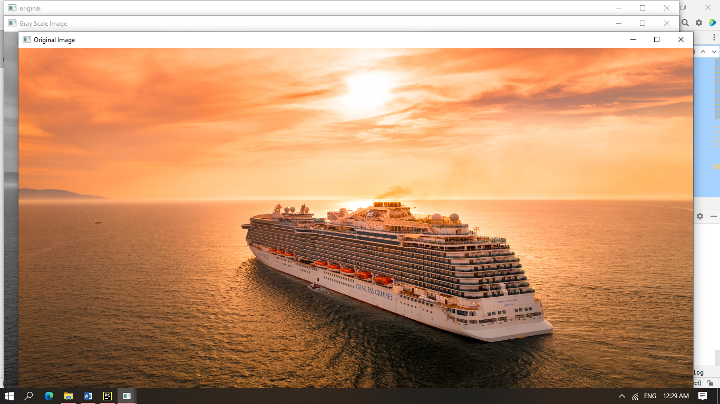

Gray Scale Image

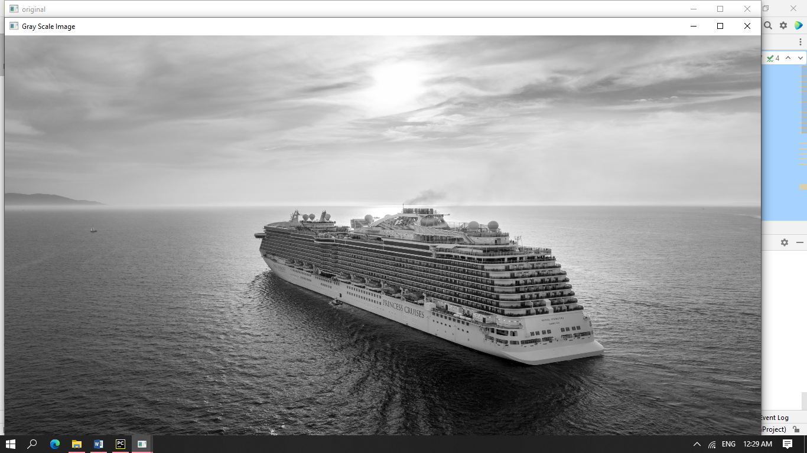

original

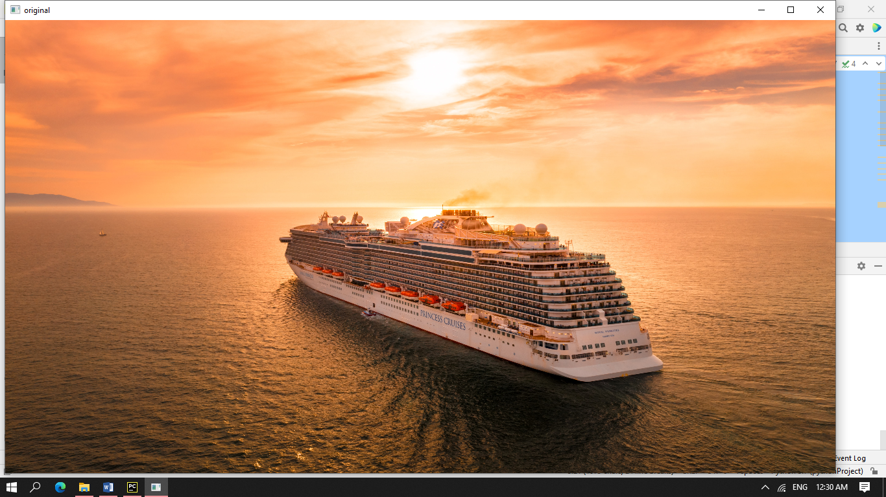

image_convesion_project.py

*# Image conversion project colored image into grayscale.*import cv2  
*# First process is to read image  
# convert image into grayscale*img1 = cv2.imread("C:\\Users\\Vishal\\PycharmProjects\\pythonProject\\Image Processing\\Data\\boat.jpg", 0)  
img1 = cv2.resize(img1, (560, 700))  
*# img1 = cv2.flip(img1, 0) # it accept 3 parameters 0,-1,1*cv2.imshow("converted image==", img1)  
k = cv2.waitKey(0) & 0xFF  
if k == ord("q"):  
 cv2.destroyAllWindows()  
  
elif k == ord("s"):  
 cv2.imwrite("C:\\Users\\Vishal\\PycharmProjects\\pythonProject\\Image Processing\\Data\\ouput.png", img1) *# it accept name of image and data* cv2.destroyAllWindows()

Output

converted image==

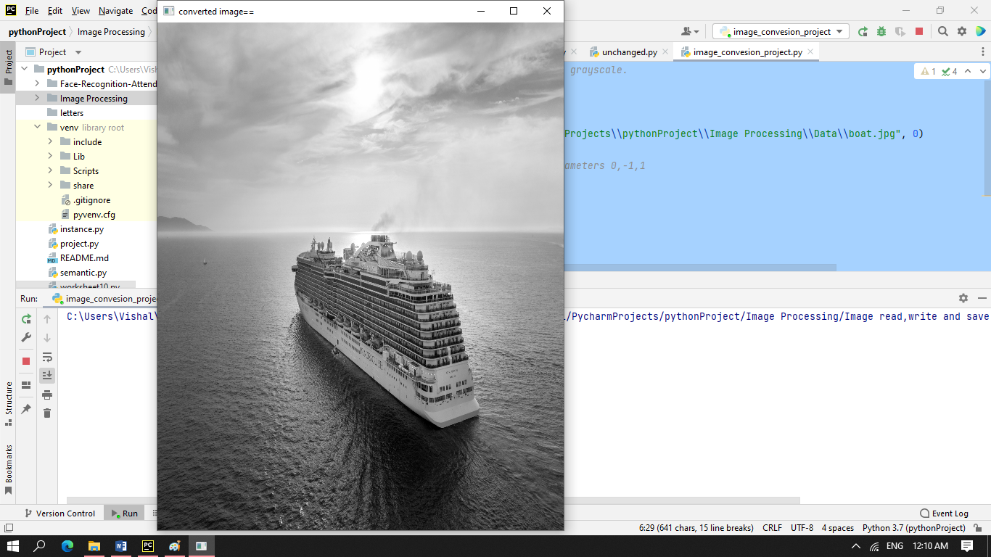

2.Read, write and save video using opencv

read_video.py

import cv2  
  
*#Here with the help of videoCapture function we easily ready any video.  
  
#Here parameter is a path of any video*cap = cv2.VideoCapture("C:\\Users\\Vishal\\PycharmProjects\\pythonProject\\Image Processing\\Data\\valorant.mp4")  
print("cap",cap)  
  
while True:  
 ret, frame = cap.read() *#here read the frame* frame = cv2.resize(frame, (700, 450))  
 cv2.imshow('frame', frame)  
 k = cv2.waitKey(25)  
 if k == ord("q"):  
 break  
*# Release everything if job is finished*cap.release()  
cv2.destroyAllWindows()

Output

frame

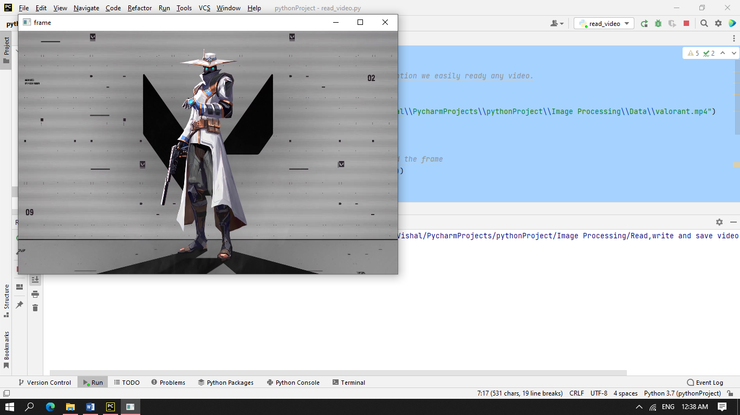

grayscale_video.py

import cv2  
  
*#Here with the help of videoCapture fucntion we easily ready any video.  
#Here parameter is a path of any video*cap = cv2.VideoCapture("C:\\Users\\Vishal\\PycharmProjects\\pythonProject\\Image Processing\\Data\\valorant.mp4")  
print("cap",cap)  
  
while True:  
 ret, frame = cap.read() *#here read the frame* frame = cv2.resize(frame, (700, 450))  
 gray = cv2.cvtColor(frame, cv2.COLOR_BGR2GRAY)  
 cv2.imshow('Colorframe', frame)  
 cv2.imshow("Gray Frame", gray)  
 k = cv2.waitKey(25)  
 if k == ord("q"):  
 break  
*# Release everything if job is finished*cap.release()  
cv2.destroyAllWindows()

Output

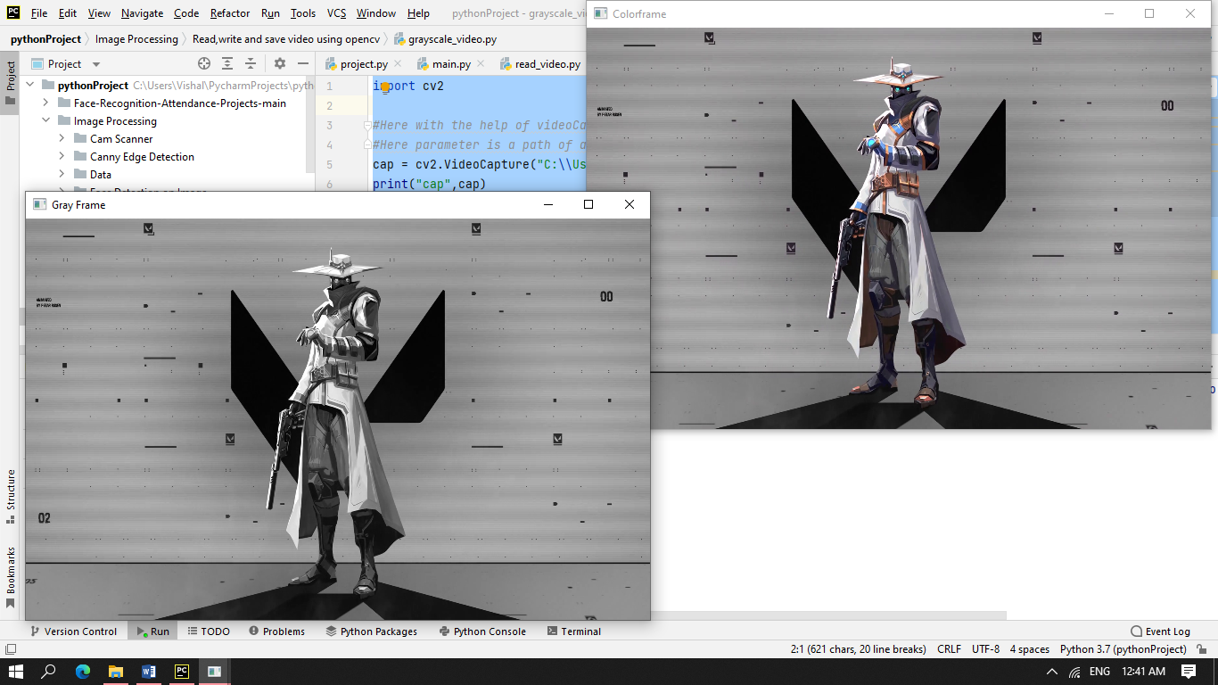

Colorframe

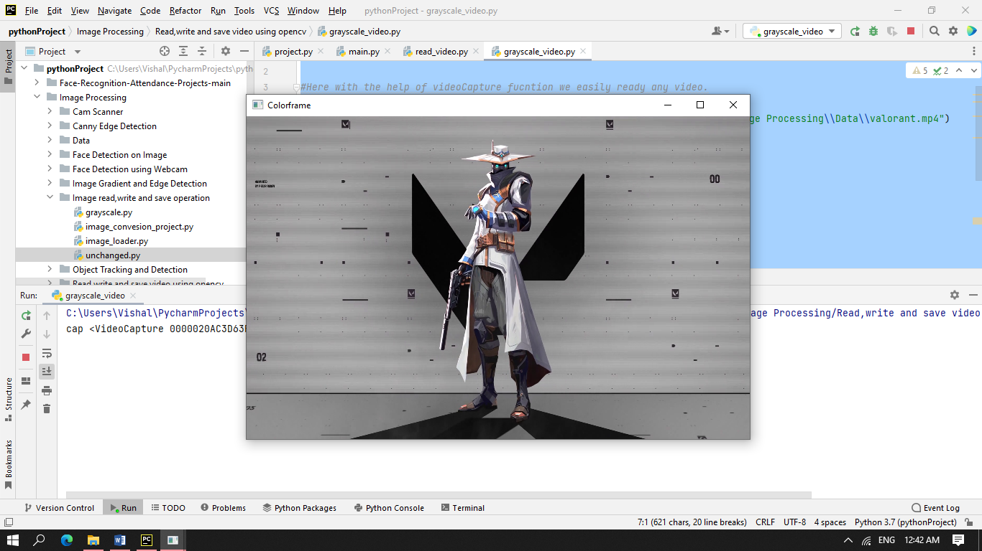

Gray Frame

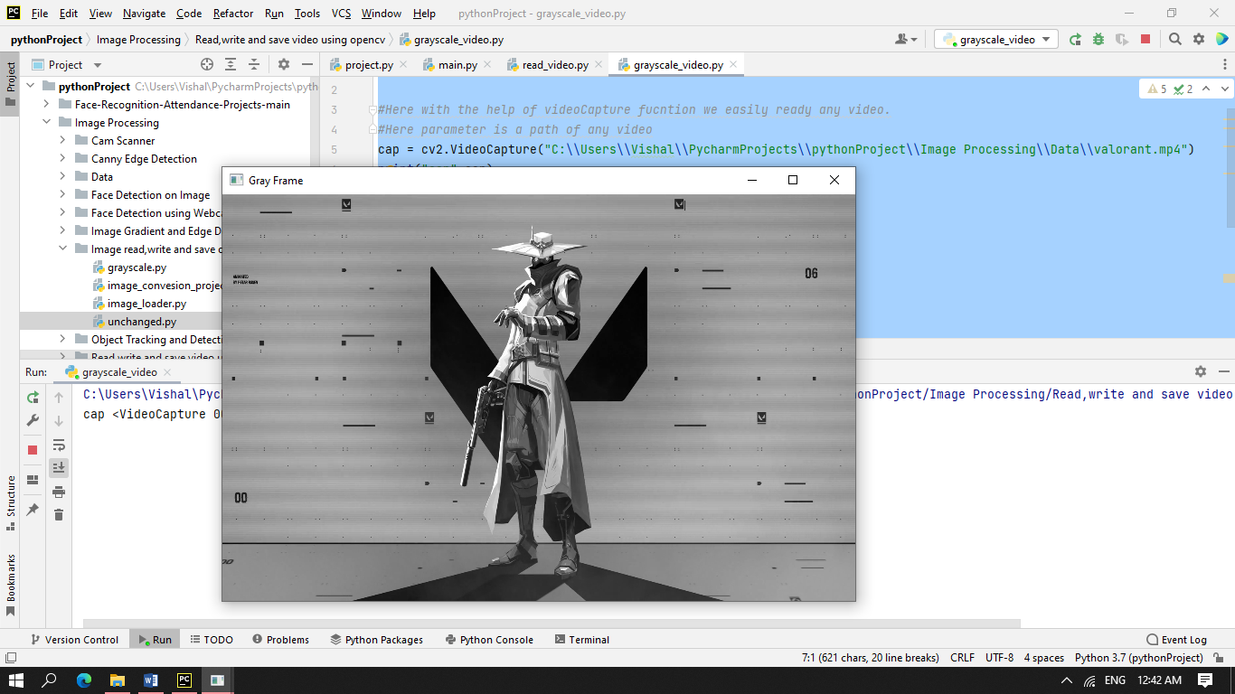

capture_webcam_video.py

*#Capture video from webcam and save it*import cv2  
  
cap = cv2.VideoCapture(0,cv2.CAP_DSHOW) *#Here parameter 0 is a path of any video use for webcam*print(cap)  
  
while(cap.isOpened()):  
 ret, frame = cap.read() *#here read the frame* if ret == True:  
 frame = cv2.resize(frame, (700, 450))  
 gray = cv2.cvtColor(frame, cv2.COLOR_BGR2GRAY)  
 cv2.imshow("Gray Frame", gray)  
 cv2.imshow('Colorframe', frame)  
 if cv2.waitKey(1) & 0xFF == ord('q'): *# press to exit* break  
  
*# Release everything if job is finished*cap.release()  
cv2.destroyAllWindows()

Output

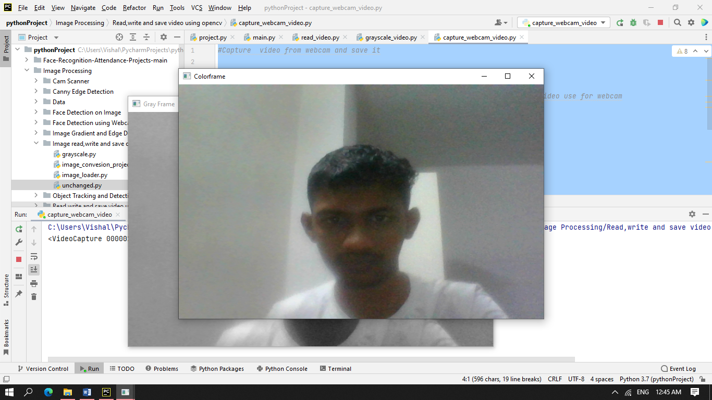

Colorframe

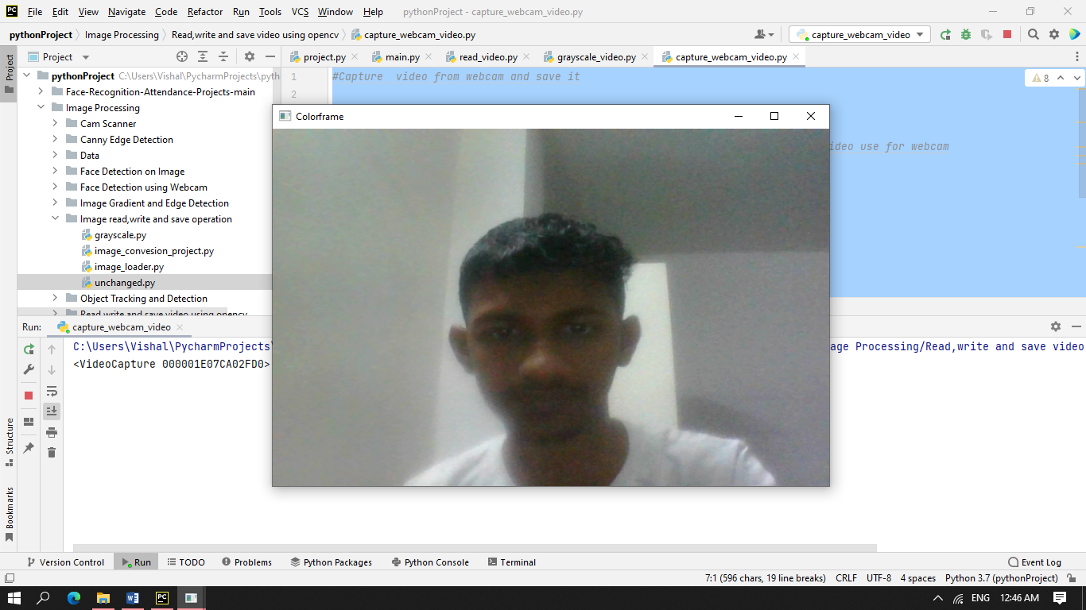

Gray Frame

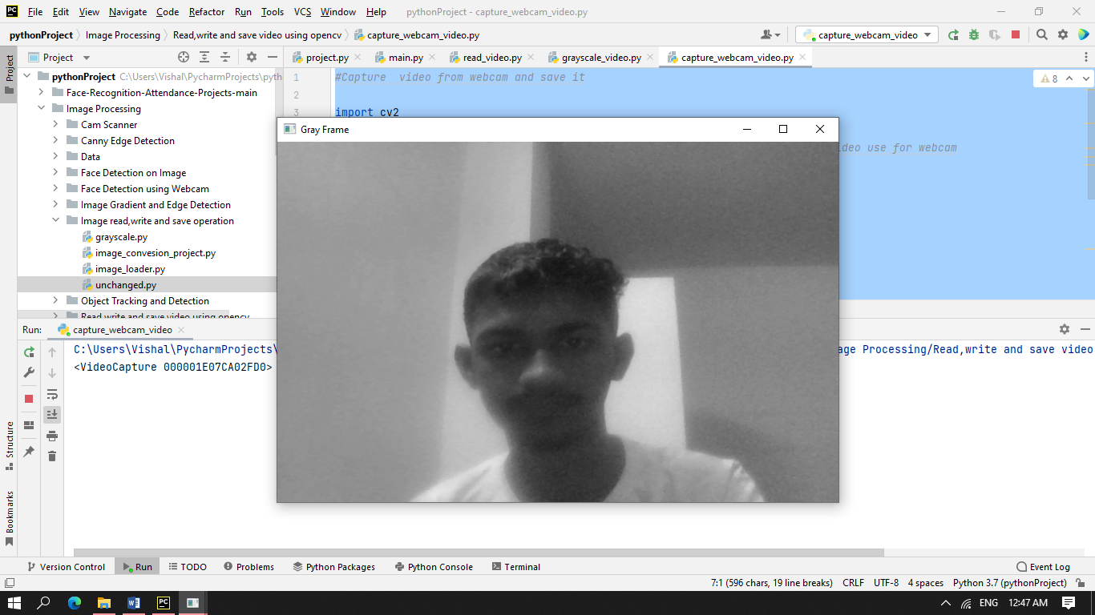

save_webcam_video_grayscale.py

*#Capture video from webcam and save it*import cv2  
cap = cv2.VideoCapture(0,cv2.CAP_DSHOW) *#Here parameter 0 is a path of any video use for webcam  
  
#it is 4 byte code which is use to specify the video codec  
#Various codec --  
#DIVX, XVID, MJPG, X264, WMV1, WMV2*fourcc = cv2.VideoWriter_fourcc(*"XVID") *# *"XVID"  
#It contain 4 parameter , name, codec,fps,resolution*output = cv2.VideoWriter("C:\\Users\\Vishal\\PycharmProjects\\pythonProject\\Image Processing\\Data\\output.avi",fourcc,20.0,(640,480),0)  
  
while(cap.isOpened()):  
 ret, frame = cap.read() *#here read the frame* if ret == True:  
 gray = cv2.cvtColor(frame, cv2.COLOR_BGR2GRAY)  
 cv2.imshow('GrayScale', gray)  
 output.write(gray)  
 if cv2.waitKey(1) & 0xFF == ord('q'): *# press to exit* break  
  
*# Release everything if job is finished*cap.release()  
output.release()  
cv2.destroyAllWindows()

Output

GrayScale

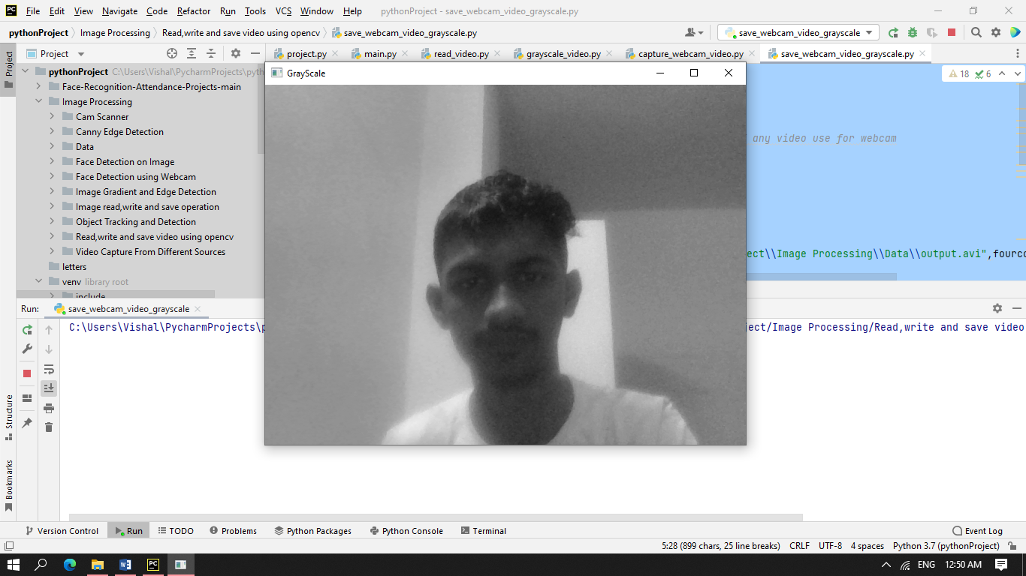

Video file saved with name *ouput.avi*

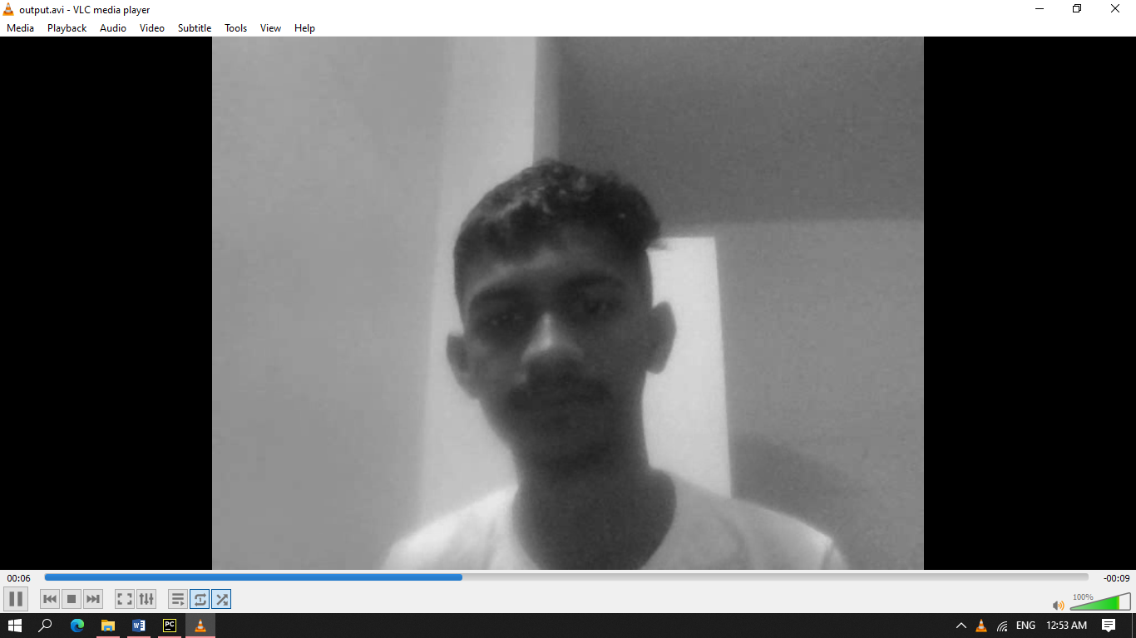

save_webcam_video.py

*#Capture video from webcam and save it*import cv2  
cap = cv2.VideoCapture(0,cv2.CAP_DSHOW) *#Here parameter 0 is a path of any video use for webcam  
  
#it is 4 byte code which is use to specify the video codec  
#Various codec --  
#DIVX, XVID, MJPG, X264, WMV1, WMV2*fourcc = cv2.VideoWriter_fourcc(*"XVID") *# *"XVID"  
#It contain 4 parameter , name, codec,fps,resolution*output = cv2.VideoWriter("C:\\Users\\Vishal\\PycharmProjects\\pythonProject\\Image Processing\\Data\\output1.avi",fourcc,20.0,(640,480))  
  
while(cap.isOpened()):  
 ret, frame = cap.read() *#here read the frame* if ret == True:  
 cv2.imshow('Colorframe', frame)  
 output.write(frame)  
 if cv2.waitKey(1) & 0xFF == ord('q'): *# press to exit* break  
  
*# Release everything if job is finished*cap.release()  
output.release()  
cv2.destroyAllWindows()

Output

Colorframe

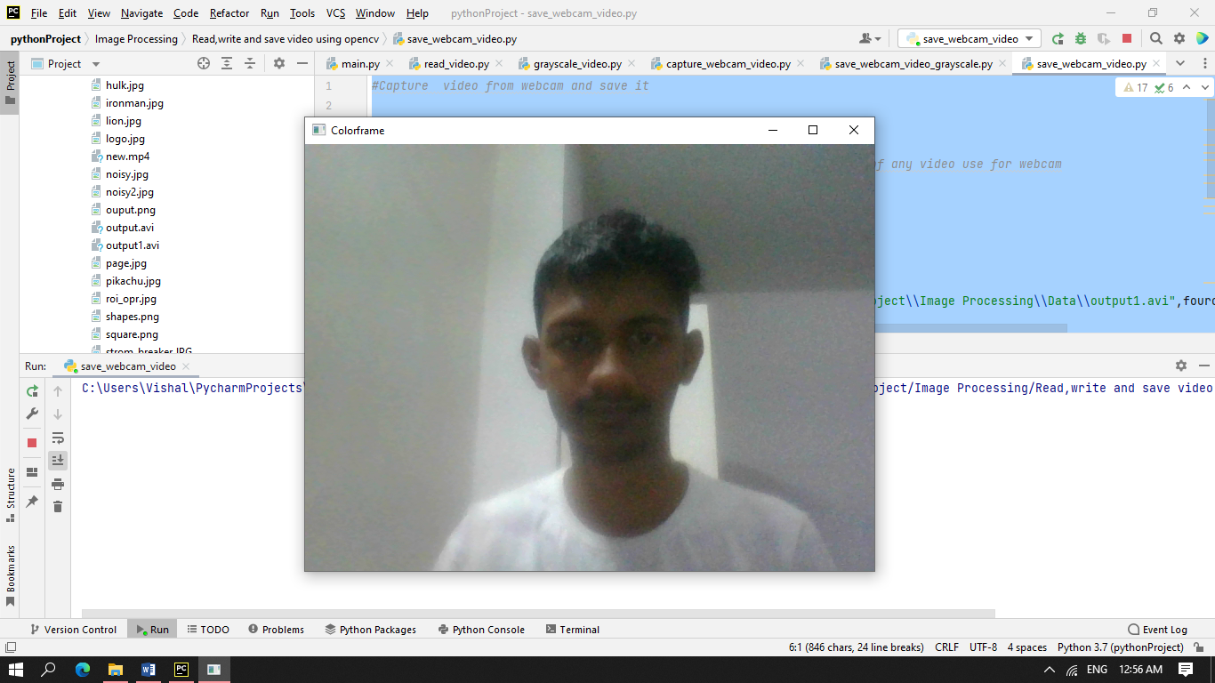

Video file saved with name *ouput1.avi*

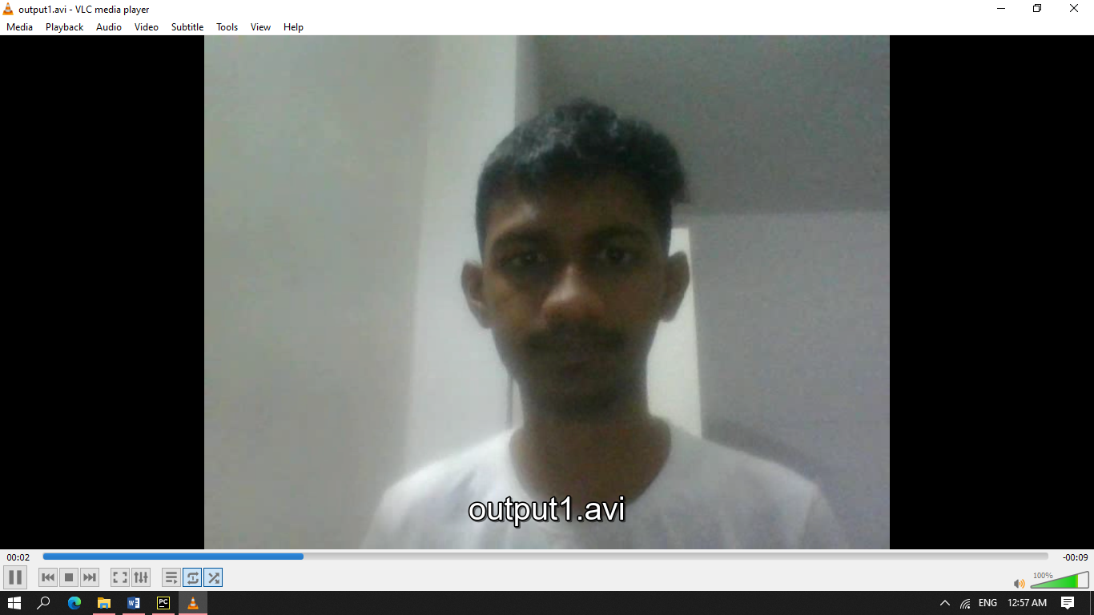

flip_video.py

*# Capture video from webcam and save it*import cv2  
cap = cv2.VideoCapture(0, cv2.CAP_DSHOW) *# Here parameter 0 is a path of any video use for webcam*print("check===", cap.isOpened())  
  
*# it is 4 byte code which is use to specify the video codec  
# Various codec --  
# DIVX, XVID, MJPG, X264, WMV1, WMV2*fourcc = cv2.VideoWriter_fourcc(*"XVID") *# *"XVID"  
# It contain 4 parameter , name, codec,fps,resolution*output = cv2.VideoWriter("C:\\Users\\Vishal\\PycharmProjects\\pythonProject\\Image Processing\\Data\\flip.avi", fourcc, 20.0, (640, 480))  
  
while (cap.isOpened()):  
 ret, frame = cap.read() *# here read the frame* if ret == True:  
  
 gray = cv2.cvtColor(frame, cv2.COLOR_BGR2GRAY)  
 *# here flip is used to lip the video at recording time* frame = cv2.flip(frame, 0)  
 output.write(frame)  
  
 cv2.imshow('Colorframe', frame)  
 if cv2.waitKey(1) & 0xFF == ord('q'): *# press to exit* break  
 else:  
 break  
  
*# Release everything if job is finished*cap.release()  
output.release()  
cv2.destroyAllWindows()

Output

Colorframe

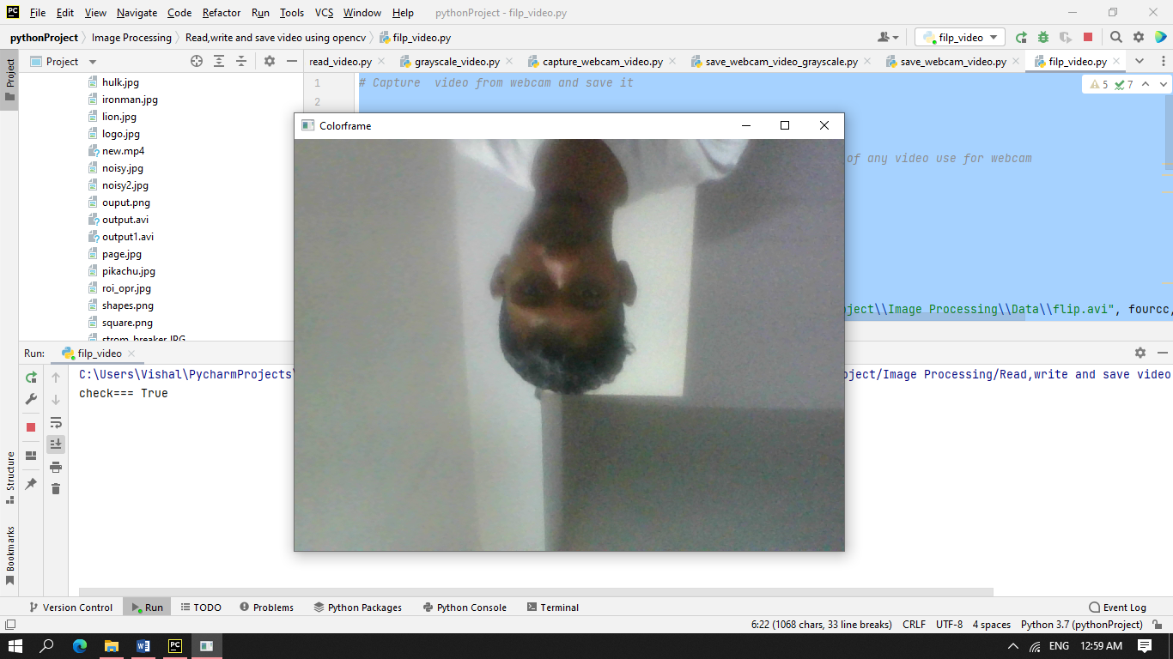

Video file saved with name *flip.avi*

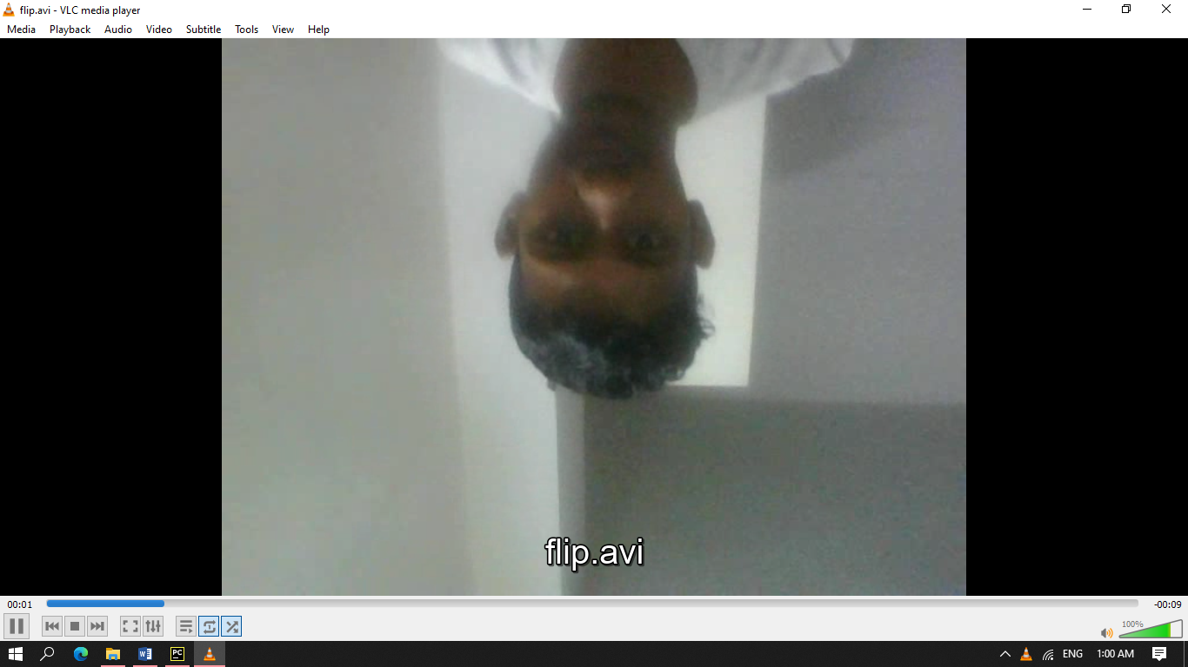

3.Video Capture from Different Sources

mobile_camera_connect.py

*#How to use android device camera as webcam in Opencv.*import cv2  
  
camera = "http://192.168.0.107:8080/video"  
*#connect your laptop and android device with same network either wifi or hotspot*cap = cv2.VideoCapture(0, cv2.CAP_DSHOW) *#Here parameter 0 is a path of any video use for webcam*cap.open(camera)  
print("check===",cap.isOpened())  
  
*#it is 4 byte code which is use to specify the video codec  
#Various codec --  
#DIVX, XVID, MJPG, X264, WMV1, WMV2*fourcc = cv2.VideoWriter_fourcc(*'MP4V') *# *"XVID"  
#It contain 4 parameter , name, codec,fps,resolution*output = cv2.VideoWriter("C:\\Users\\Vishal\\PycharmProjects\\pythonProject\\Image Processing\\Data\\output.mp4",fourcc,20.0,(640,480))  
  
while(cap.isOpened()):  
 ret, frame = cap.read() *#here read the frame* if ret == True:  
 frame = cv2.resize(frame, (700, 700))  
 cv2.imshow('Colorframe', frame)  
 output.write(frame)  
 if cv2.waitKey(1) & 0xFF == ord('q'): *# press to exit* break  
  
*# Release everything if job is finished*cap.release()  
output.release()  
cv2.destroyAllWindows()

Output

Colorframe

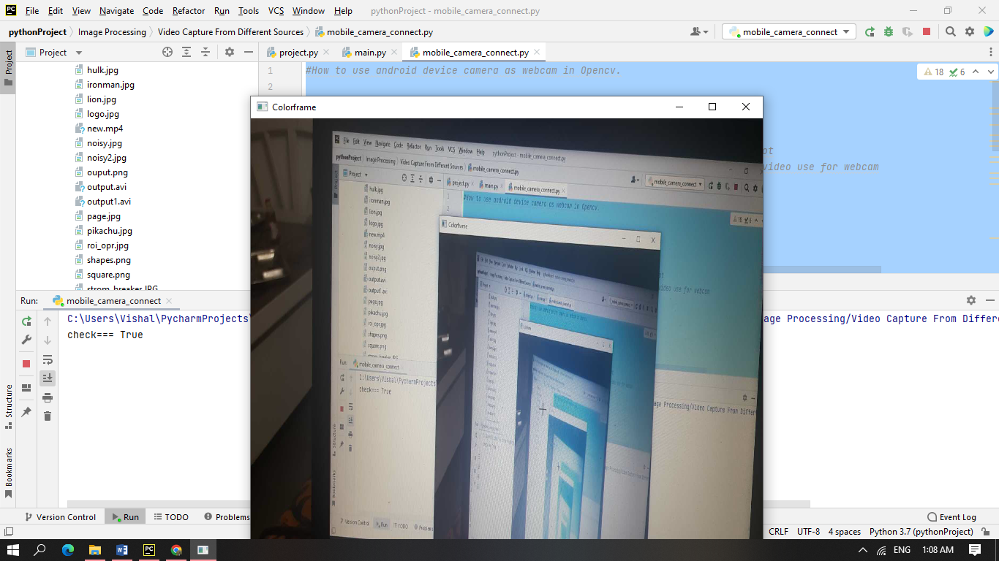

<http://192.168.0.107:8080> opened on browser

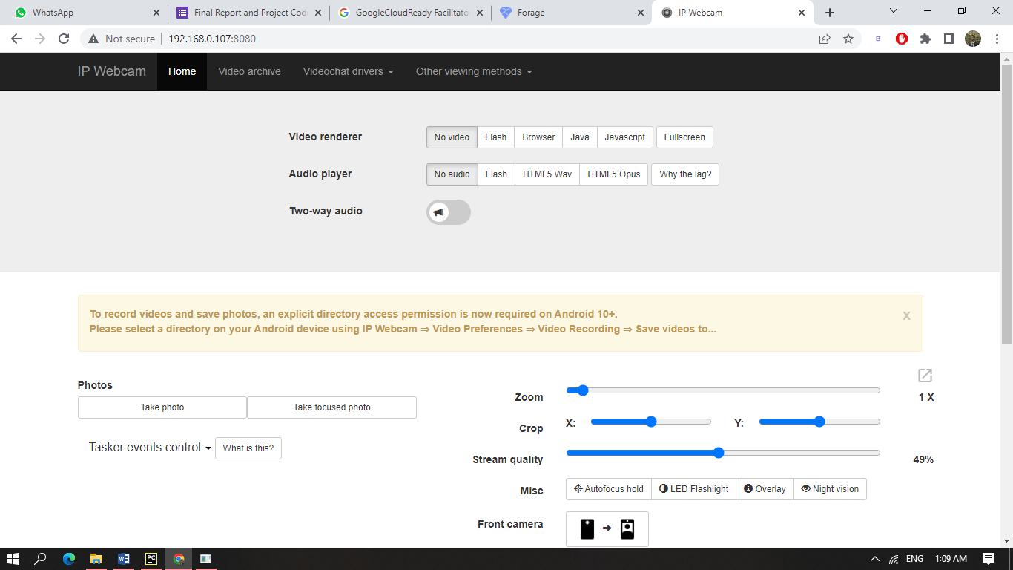

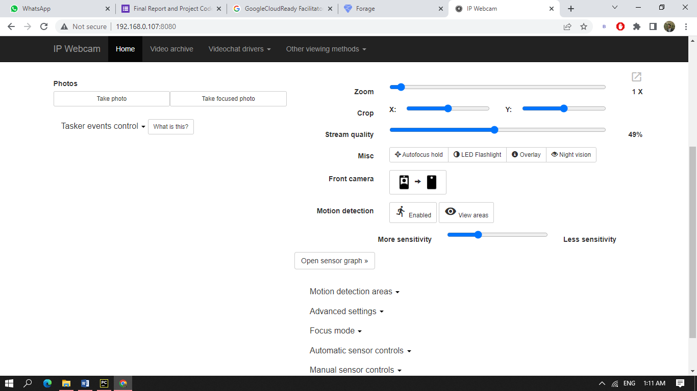

View from laptop

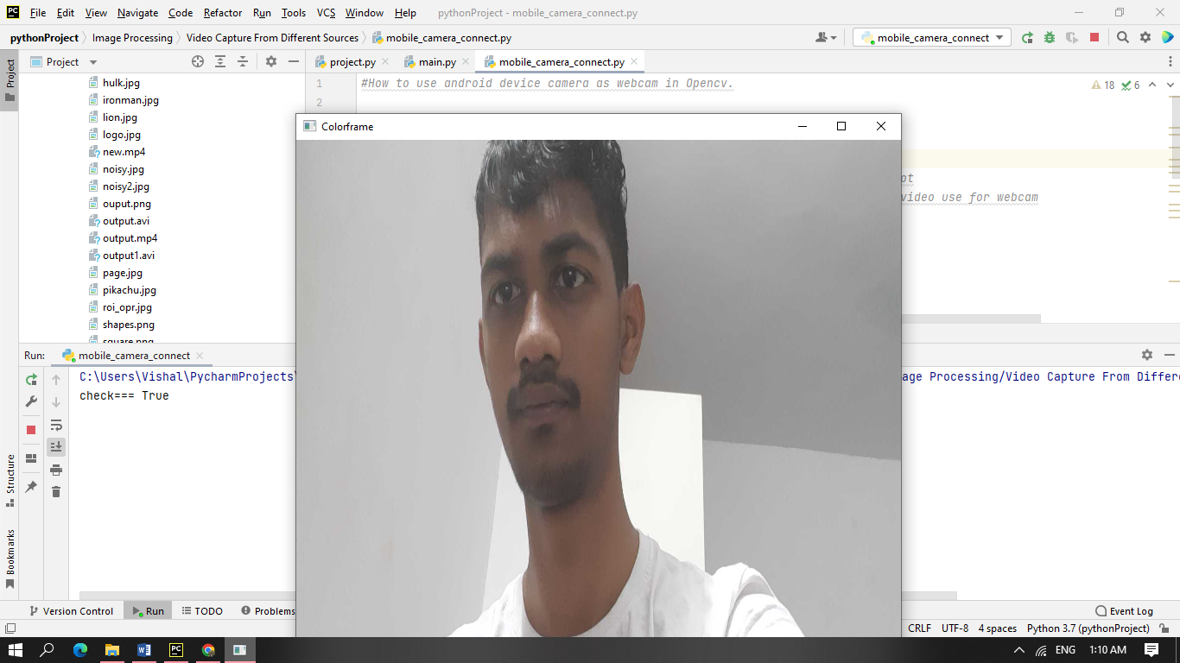

View from android on IP Webcam App

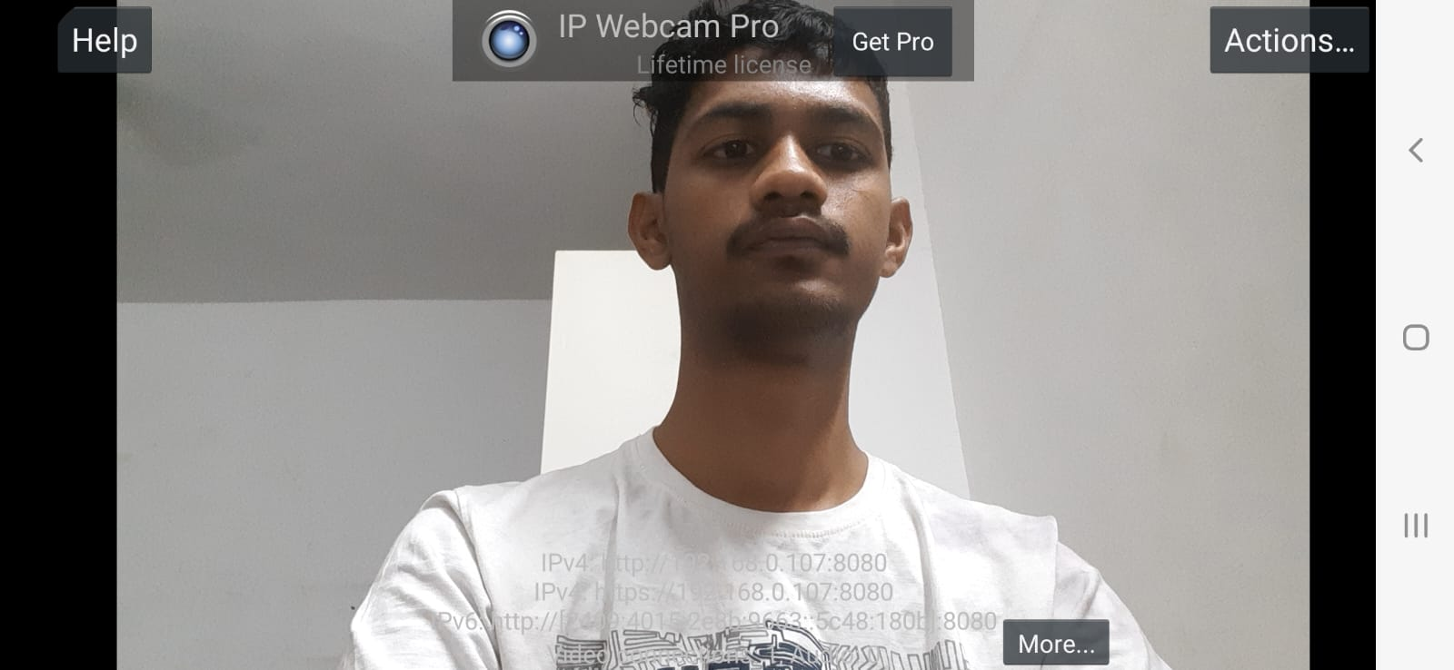

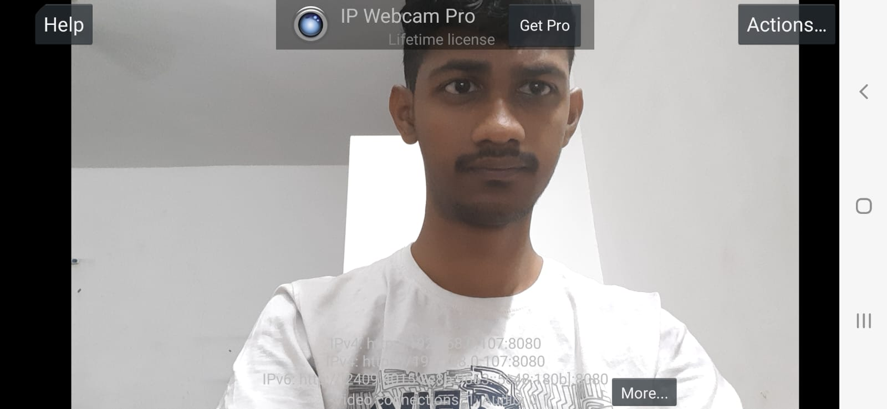

youtube_vid_capture.py

*# Capture video from youtube*import pafy  
import cv2  
url = "https://www.youtube.com/watch?v=SLD9xzJ4oeU"  
data = pafy.new(url )  
data = data.getbest(preftype="mp4")  
cap = cv2.VideoCapture() *#Here parameter 0 is a path of any video use for webcam*cap.open(data.url)  
  
while(cap.isOpened()):  
 ret, frame = cap.read() *#here read the frame* if ret==True:  
 frame = cv2.resize(frame, (700, 700))  
 gray = cv2.cvtColor(frame,cv2.COLOR_BGR2GRAY)  
 *#here flip is used to lip the video at recording time  
 #frame = cv2.flip(frame,0)  
 #output.write(gray)* cv2.imshow("Gray Frame",gray)  
 cv2.imshow('Colorframe',frame)  
 if cv2.waitKey(1) & 0xFF == ord('q'): *#press to exit* break  
 else:  
 break  
  
*# Release everything if job is finished*cap.release()  
cv2.destroyAllWindows()

Output

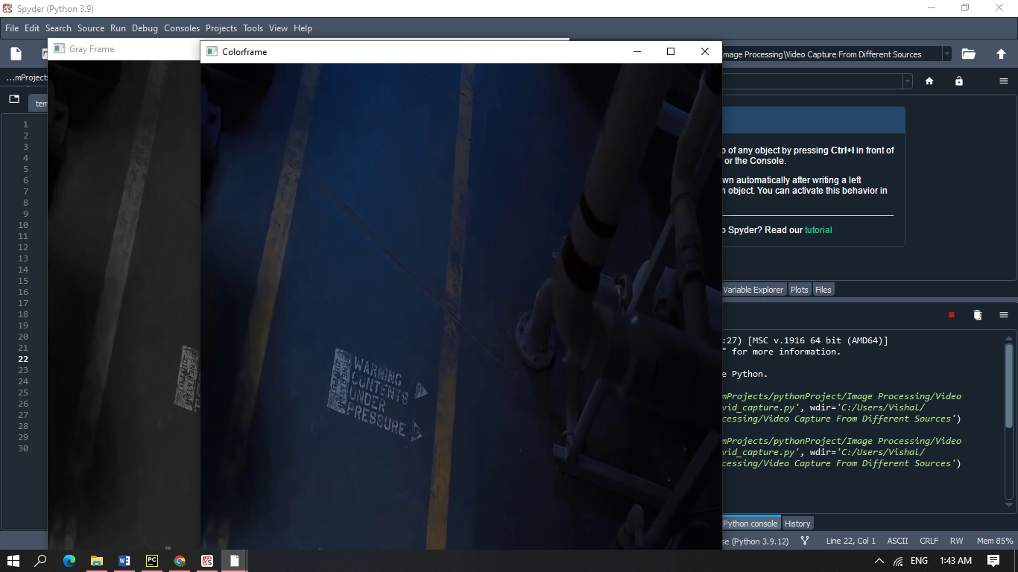

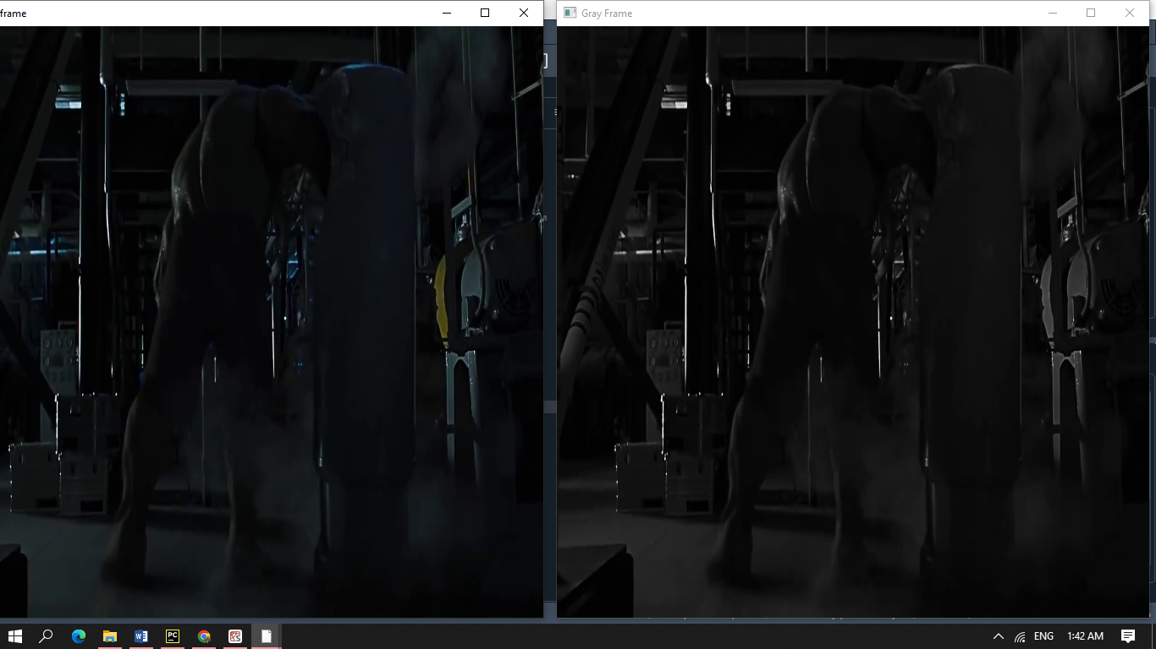

4.Image Gradient and Edge Detection

img_grd_and_edge_detection.py

*# Image Gradient--  
# It is a directional change in the color or intensity in an image.  
# It is most important part to find information from image  
# Like finding edges within the images.  
# There are various methods to find image gradient.  
# These are - Laplacian Derivatives, SobelX and SobelY.  
# All these functions have diff. mathematical approach to get result.  
# All load image in the gray scale  
  
# Don't Worry about Mathematics behind all these function  
# we just use these to get our work in easy manner.*import cv2  
import numpy as np  
  
*# load image into gray scale*img = cv2.imread("C:\\Users\\Vishal\\PycharmProjects\\pythonProject\\Image Processing\\Data\\page.jpg")  
img = cv2.resize(img, (400, 300))  
img_gray = cv2.cvtColor(img, cv2.COLOR_BGR2GRAY)  
  
*# Laplacian Derivative---It calculate laplace derivate  
# parameter(img,data_type for -ve val,ksize)  
# kernal size must be odd*lap = cv2.Laplacian(img_gray, cv2.CV_64F, ksize=3) *# also pass kernal size*lap = np.uint8(np.absolute(lap))  
  
*# Sobel operation -  
# is a joint Gausssian smoothing plus differentiation operation,  
# so it is more resistant to noise  
# This is use for x and y bth  
# parameter (img,type for -ve val,x = 1,y = 0,ksize)  
# Sobel X focus on vertical lines  
# Sobel y focus on horizontal lines*sobelX = cv2.Sobel(img_gray, cv2.CV_64F, 1, 0, ksize=3) *# here 1 means x direction*sobelY = cv2.Sobel(img_gray, cv2.CV_64F, 0, 1, ksize=3) *# here 1 means y direction*sobelX = np.uint8(np.absolute(sobelX))  
sobelY = np.uint8(np.absolute(sobelY))  
  
*# finally combine sobelX and sobelY together*sobelcombine = cv2.bitwise_or(sobelX, sobelY)  
  
cv2.imshow("original==", img)  
cv2.imshow("gray====", img_gray)  
cv2.imshow("Laplacian==", lap)  
cv2.imshow("SobelX===", sobelX)  
cv2.imshow("SobelY==", sobelY)  
cv2.imshow("COmbined image==", sobelcombine)  
  
*# Now plot all the images on graph*titles = ["original", "gray", "laplacian", "sobelX", "sobelY", "combined"]  
images = [img, img_gray, lap, sobelX, sobelY, sobelcombine]  
  
*# if you want then plot it*from matplotlib import pyplot as plt  
  
for i in range(6):  
 plt.subplot(3, 2, i + 1),  
 plt.imshow(images[i], 'gray')  
 plt.title(titles[i])  
 plt.xticks([]), plt.yticks([])  
  
cv2.waitKey(0)  
cv2.destroyAllWindows()

Output

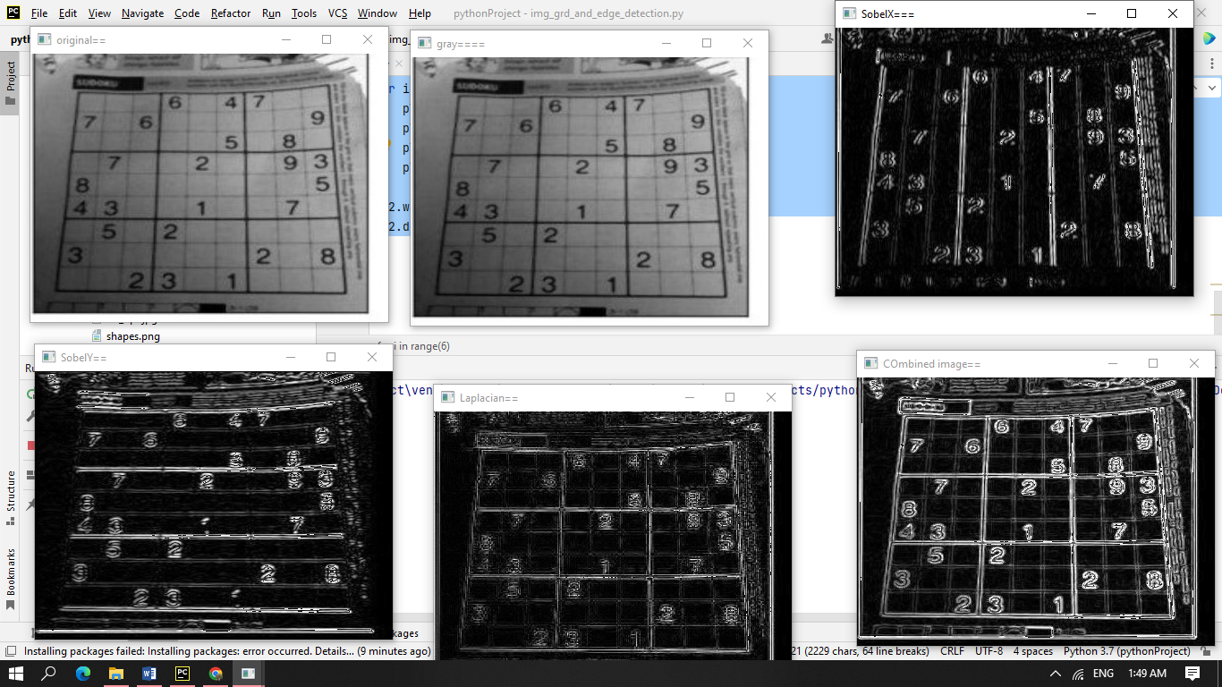

5.Canny Edge Detection

canny_edge.py

import cv2  
import numpy as np  
  
*#load image into gray scale*img = cv2.imread("C:\\Users\\Vishal\\PycharmProjects\\pythonProject\\Image Processing\\Data\\building.jpg")  
img = cv2.resize(img,(600,700))  
img_gray = cv2.cvtColor(img,cv2.COLOR_BGR2GRAY)  
*#canny(img,thresh1,thres2)thresh 1 and thresh2 at different lvl*canny = cv2.Canny(img_gray,20,150)  
cv2.imshow("original==",img)  
cv2.imshow("gray====",img_gray)  
cv2.imshow("canny==",canny)  
cv2.waitKey(0)  
cv2.destroyAllWindows()

Output

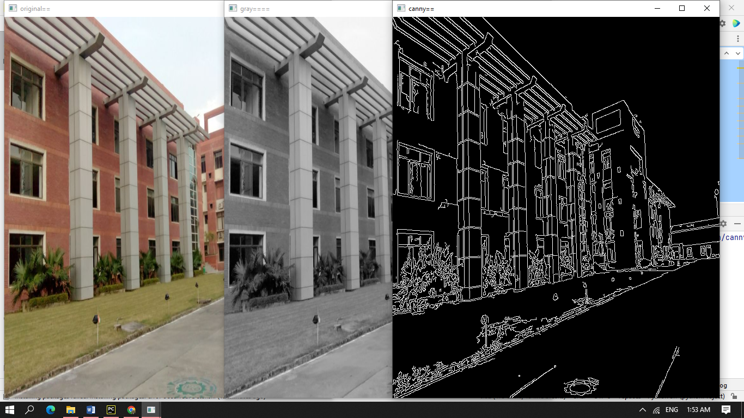

original==

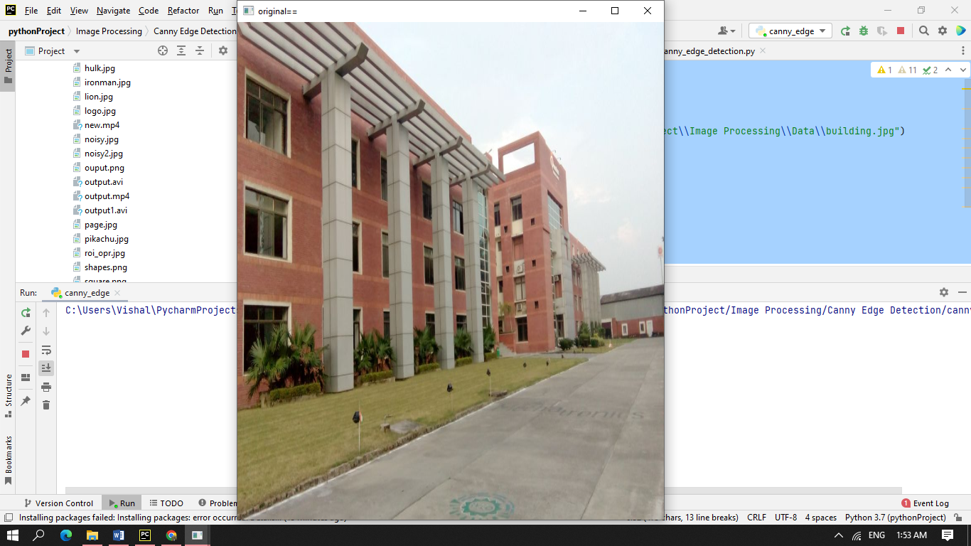

gray====

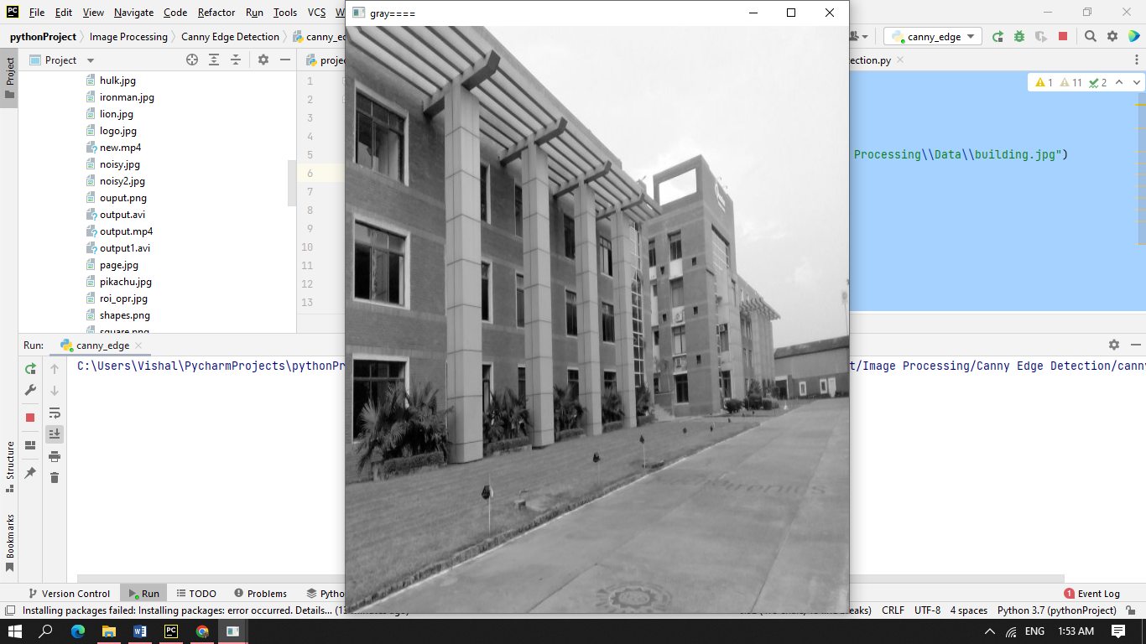

canny==

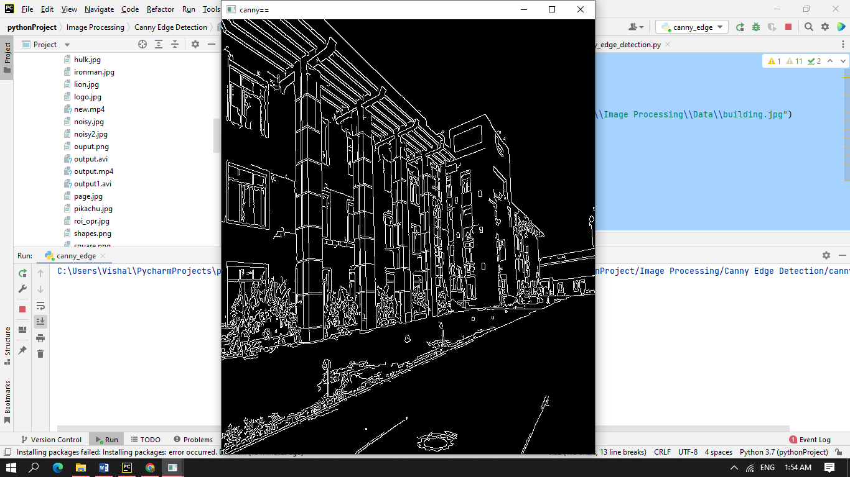

canny_edge_detection.py

*#Canny Edge Detection using OpenCV  
#Canny Edge Detection is a popular edge detection approach.  
#It is use multi-stage algorithm to detect a edges.  
#It was developed by John F. Canny in 1986.  
#This approach combine with 5 steps.  
# 1) - Noise reduction(gauss)), 2) -Gradient calculation( ,  
# 3) - Non-maximum suppression, 4) - Double Threshold,  
# 5) - Edge Tracking by Hysteresis*import cv2  
import numpy as np  
  
*# building trackbar with canny edge  
# load image into gray scale*img = cv2.imread("C:\\Users\\Vishal\\PycharmProjects\\pythonProject\\Image Processing\\Data\\building.jpg")  
img = cv2.resize(img, (600, 700))  
img_gray = cv2.cvtColor(img, cv2.COLOR_BGR2GRAY)  
  
  
def nothing(x):  
 pass  
  
cv2.namedWindow("Canny")  
cv2.createTrackbar("Threshold", "Canny", 0, 255, nothing)  
  
while True:  
 a = cv2.getTrackbarPos('Threshold', 'Canny')  
  
 print(a)  
 res = cv2.Canny(img_gray, a, 255)  
 cv2.imshow("Canny", res)  
 k = cv2.waitKey(1) & 0xFF  
 if k == 27:  
 break  
  
cv2.destroyAllWindows()

Output

Threshold at 0

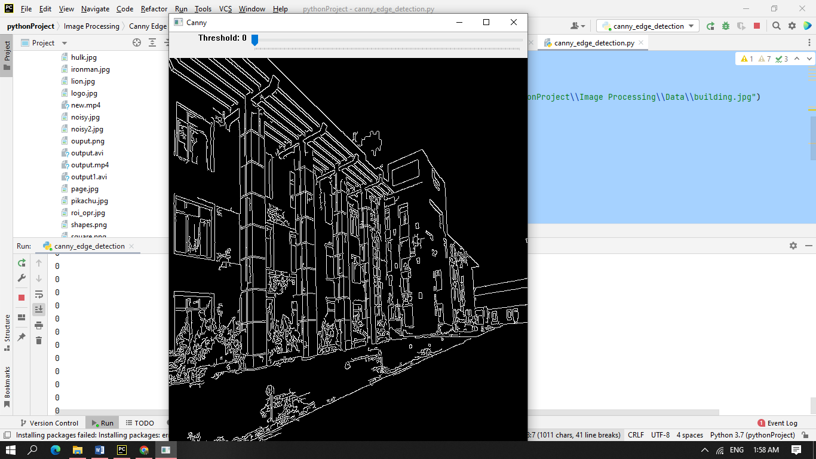

Threshold at 90

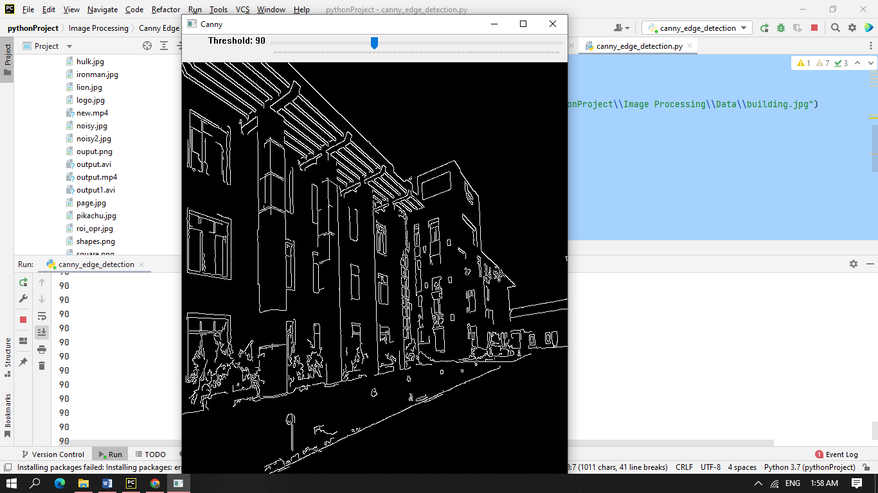

Threshold at 150

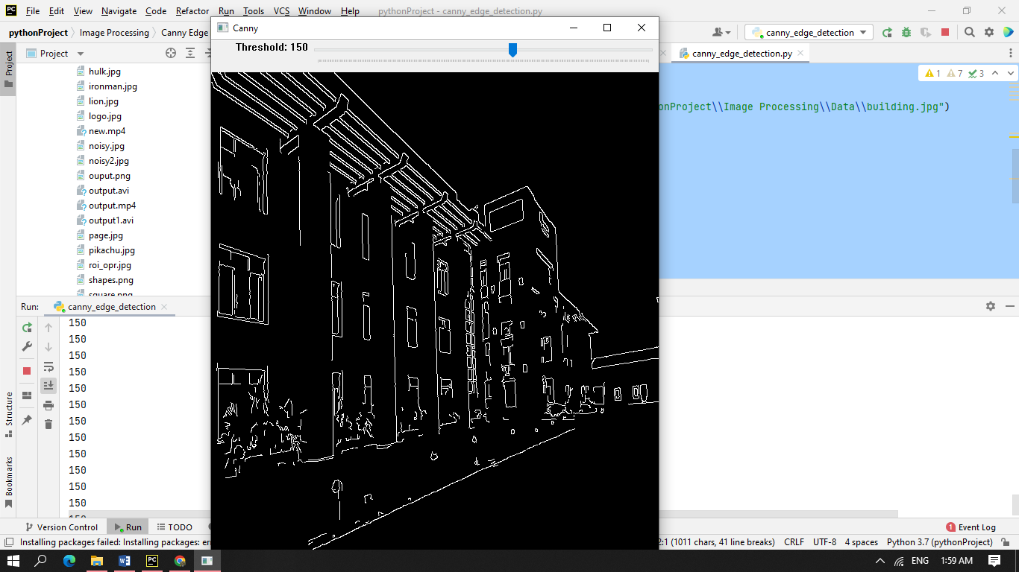

Threshold at 255

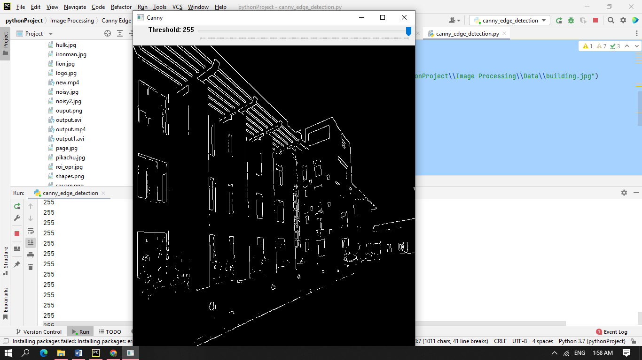

6.Face Detection on Image

face_and_eye_detection.py

*# Face Detection using haarcascade file*import cv2  
import numpy  
  
face = cv2.CascadeClassifier("C:\\Users\\Vishal\\PycharmProjects\\pythonProject\\Image Processing\\Data\cascades\\haarcascade_frontalface_default.xml") *# for detecting face*eye = cv2.CascadeClassifier('C:\\Users\\Vishal\\PycharmProjects\\pythonProject\\Image Processing\\Data\\cascades\\haarcascade_eye.xml') *# for detecting eyes*image = cv2.imread("C:\\Users\\Vishal\\PycharmProjects\\pythonProject\\Image Processing\\Data\\a.jpg")  
gray = cv2.cvtColor(image, cv2.COLOR_BGR2GRAY) *# convert into gray  
  
# parameters(img,scale_factor[reduce image size],min_neighbour)*faces = face.detectMultiScale(gray, 4, 4) *# for faces*for (x, y, w, h) in faces:  
  
 image = cv2.rectangle(image, (x, y), (x + w, y + h), (127, 0, 205), 3)  
  
 *# Now detect eyes* roi_gray = gray[y:y + h, x:x + w]  
 roi_color = image[y:y + h, x:x + w]  
 eyes = eye.detectMultiScale(roi_gray, 1.2, 1)  
 for (ex, ey, ew, eh) in eyes:  
 cv2.rectangle(roi_color, (ex, ey), (ex + ew, ey + eh), (255, 0, 0), 2)  
  
image = cv2.resize(image, (800, 700))  
cv2.imshow("Face Detected", image)  
cv2.waitKey(0)  
cv2.destroyAllWindows()

Output

original image *a.jpg*



Face and eye detection

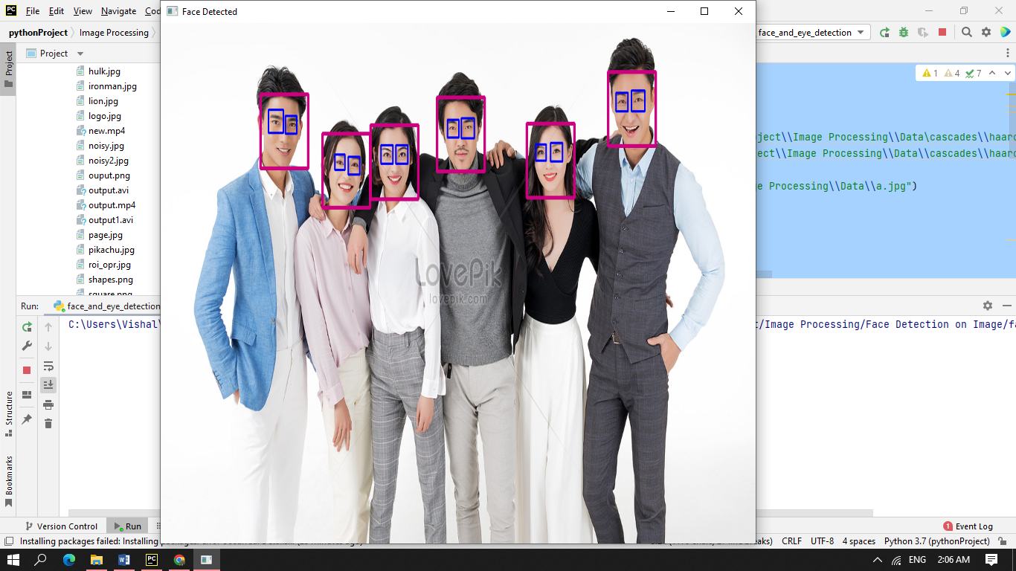

7.Face Detection using Webcam

face_detection_using_webcam.py

import cv2  
import numpy  
  
face = cv2.CascadeClassifier("C:\\Users\\Vishal\\PycharmProjects\\pythonProject\\Image Processing\\Data\\cascades\\haarcascade_frontalface_default.xml")  
eye = cv2.CascadeClassifier('C:\\Users\\Vishal\\PycharmProjects\\pythonProject\\Image Processing\\Data\cascades\\haarcascade_eye.xml') *# for detecting eyes*def dector(img):  
 gray = cv2.cvtColor(img, cv2.COLOR_BGR2GRAY)  
 faces = face.detectMultiScale(gray, 1.3, 5)  
  
 for (x, y, w, h) in faces:  
 cv2.rectangle(img, (x, y), (x + w, y + h), (127, 0, 125), 3)  
  
 roi_gray = gray[y:y + h, x:x + w]  
  
 roi_color = img[y:y + h, x:x + w]  
  
 eyes = eye.detectMultiScale(roi_gray, 1.3, 3)  
 for (ex, ey, ew, eh) in eyes:  
 cv2.circle(roi_color, (ex + 27, ey + 27), 20, (255, 255, 0), 2)  
  
 return img  
  
  
cap = cv2.VideoCapture(0, cv2.CAP_DSHOW)  
while True:  
 ret, frame = cap.read()  
 frame = cv2.flip(frame, 2)  
 cv2.imshow("face dect", dector(frame))  
 if cv2.waitKey(1) == 13: *# press enter to terminate* break  
  
cap.release()  
cv2.destroyAllWindows()

Output

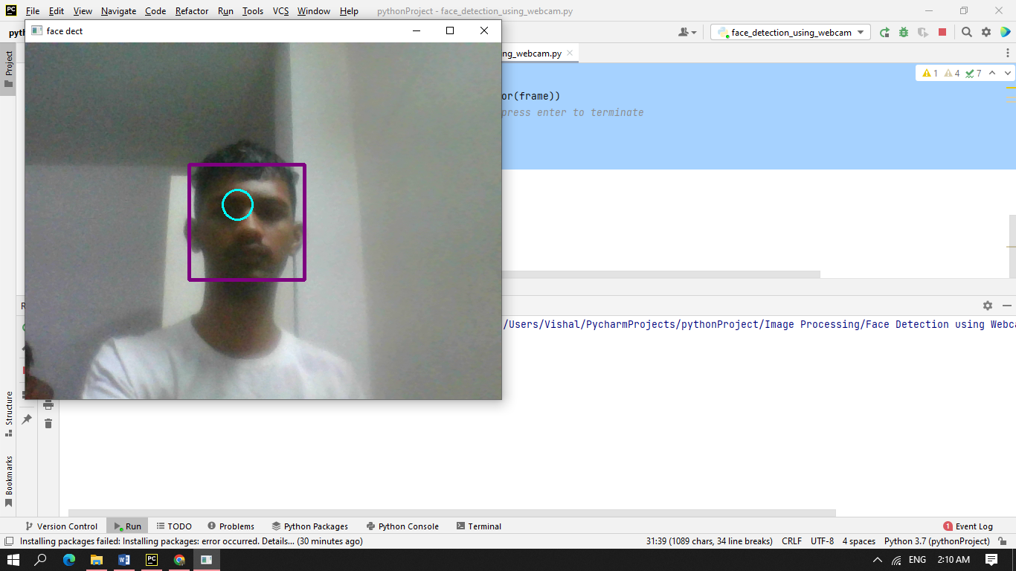

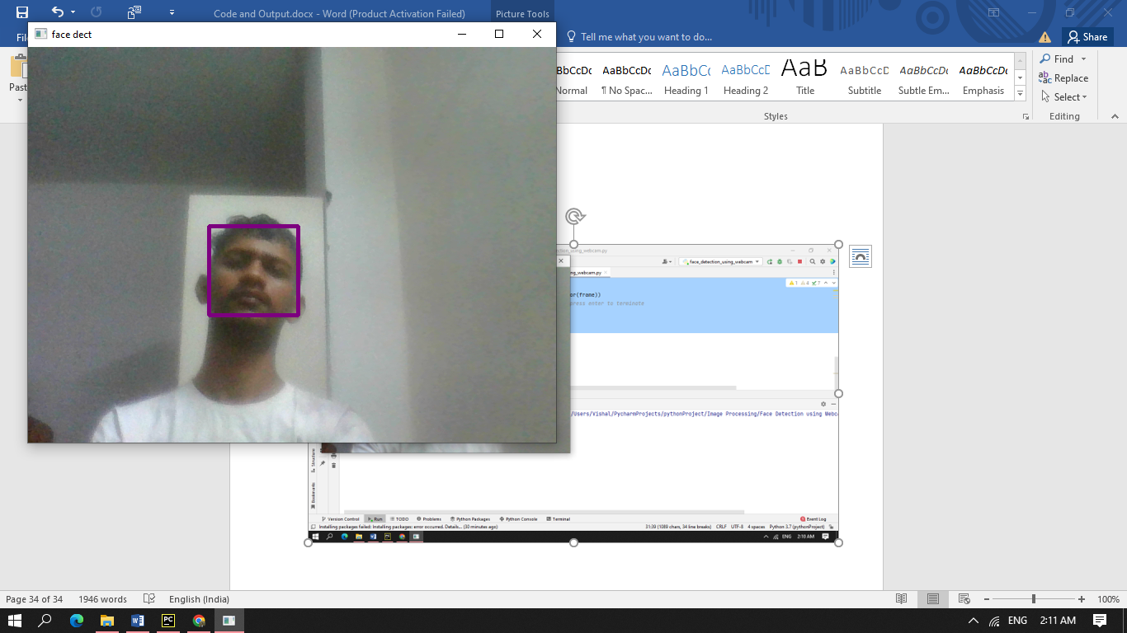

8.Object Tracking and Detection

camshift_obj_detection_and _tracking.py

*# CAMshift (Continuously Adaptive Meanshift)*import numpy as np  
import cv2 as cv  
  
cap = cv.VideoCapture('C:\\Users\\Vishal\\PycharmProjects\\pythonProject\\Image Processing\\Data\\test2.mp4')  
  
*# take first frame of the video*ret, frame = cap.read()  
  
*# setup initial location of window*x, y, width, height = 580, 30, 80, 150  
track = (x, y, width, height)  
  
*# set up the ROI for tracking*roi = frame[y:y + height, x: x + width]  
hsv_roi = cv.cvtColor(roi, cv.COLOR_BGR2HSV)  
mask = cv.inRange(hsv_roi, np.array((0., 60., 32.)), np.array((180., 255., 255)))  
roi_hist = cv.calcHist([hsv_roi], [0], mask, [180], [0, 180])  
cv.normalize(roi_hist, roi_hist, 0, 255, cv.NORM_MINMAX)  
  
*# Setup the termination criteria, either 10 iteration or move by atleast 1 pt*termntn = (cv.TERM_CRITERIA_EPS | cv.TERM_CRITERIA_COUNT, 10, 1)  
cv.imshow('roi', roi)  
while True:  
 ret, frame = cap.read()  
  
 if ret == True:  
  
 hsv = cv.cvtColor(frame, cv.COLOR_BGR2HSV)  
 dst = cv.calcBackProject([hsv], [0], roi_hist, [0, 180], 1)  
  
 *# apply meanshift to get the new location* ret, track = cv.CamShift(dst, track, termntn)  
  
 *# Draw it on image  
 # x,y,w,h = track  
 # final = cv.rectangle(frame, (x,y), (x+w, y+h), (0,0,255), 3)*

*# Try to draw rotating rectangle* pts = cv.boxPoints(ret)  
 pts = np.int64(pts)  
 final = cv.polylines(frame, [pts], True, (255, 0, 0), 2)  
  
 cv.imshow('dst', dst)  
 frame = cv.resize(final, (600, 600))  
 cv.imshow('final_image', frame)  
 k = cv.waitKey(30) & 0xff  
 if k == 27:  
 break  
 else:  
 break  
cv.destroyAllWindows()

Output

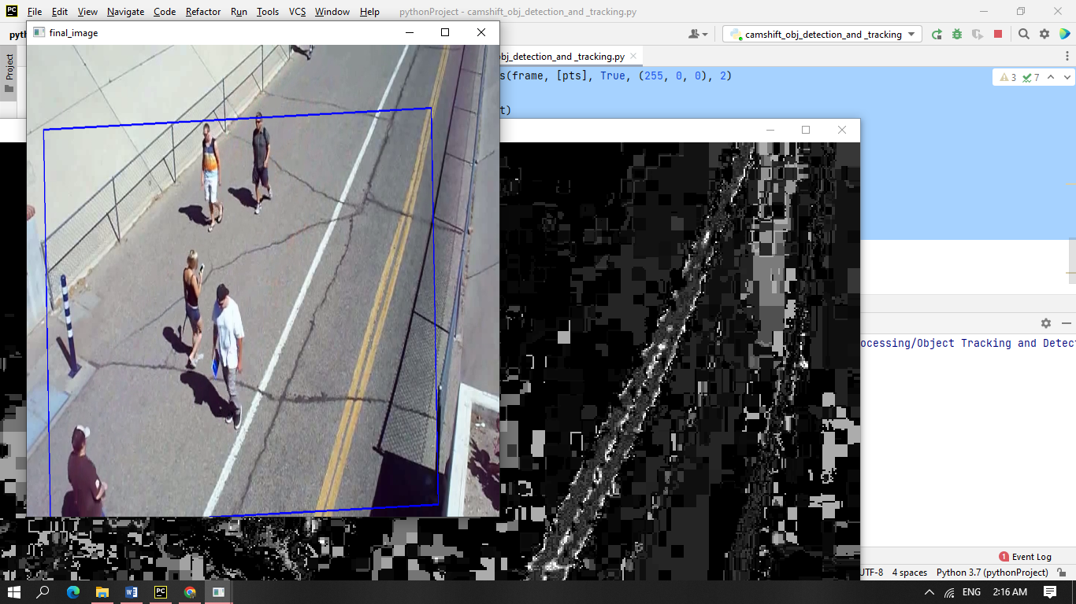

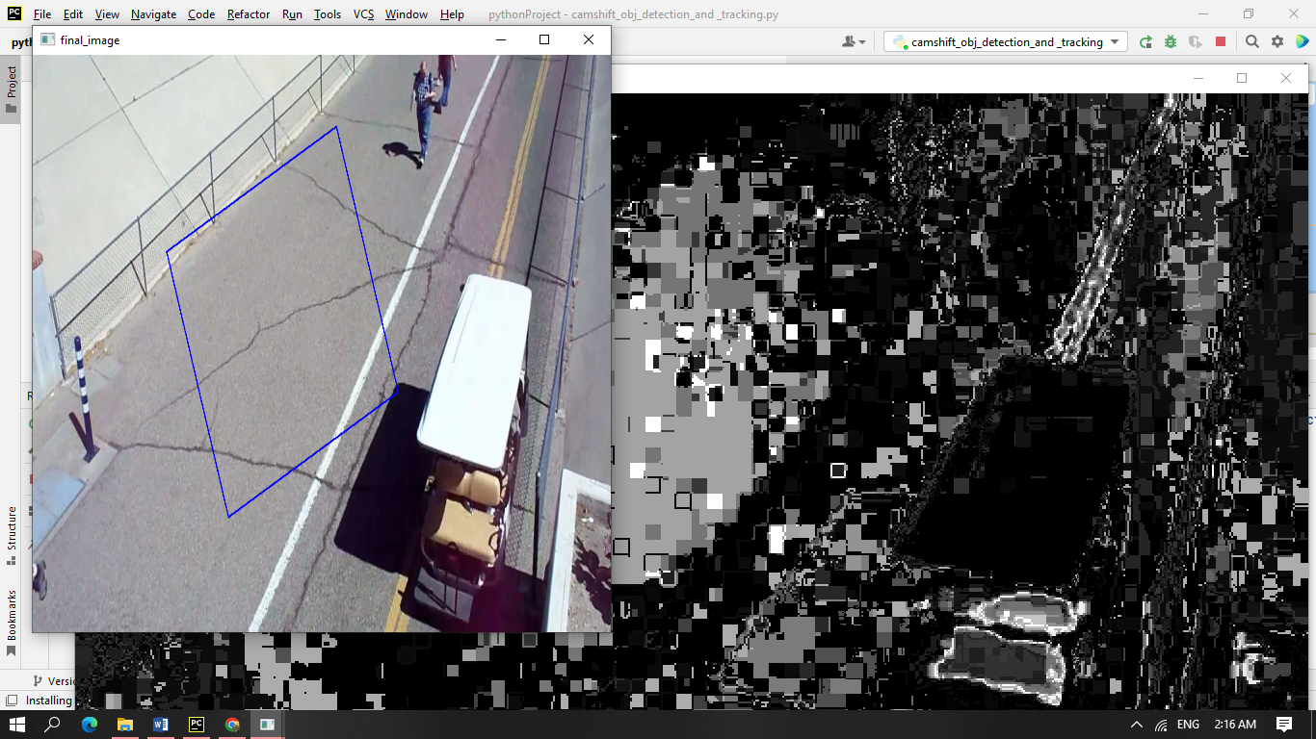

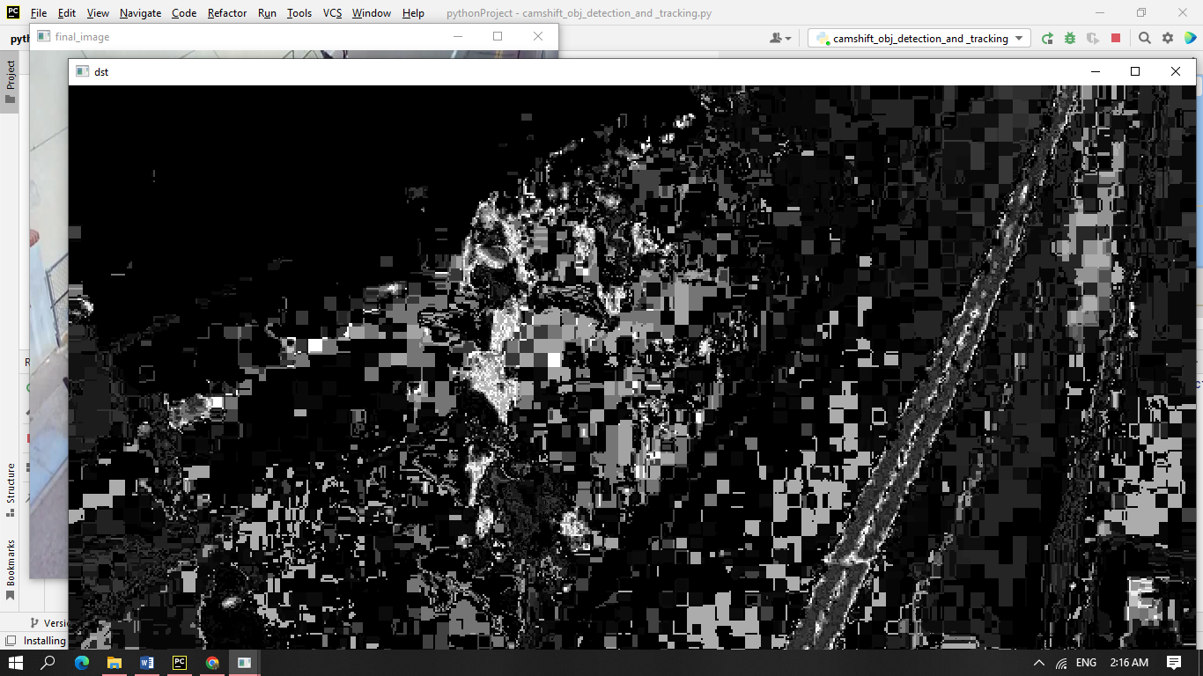

object_tracking_and _detection.py

*# Object Tracking using Meanshift Algo.  
# The idea behind this algo is to move small window to get the high  
# density pixels same as histogram backprojection.  
  
# Steps to use this algo-----  
# First setup target and find its histogram for backproject the target.  
# Also set one initial location  
# setup the termination criteria*import numpy as np  
import cv2 as cv  
  
cap = cv.VideoCapture('C:\\Users\\Vishal\\PycharmProjects\\pythonProject\\Image Processing\\Data\\test2.mp4')  
  
*# take first frame of the video*ret, frame = cap.read()  
  
*# setup initial location of window*x, y, width, height = 580, 30, 80, 150  
track = (x, y, width, height)  
  
*# set up the ROI for tracking*roi = frame[y:y + height, x: x + width]  
hsv_roi = cv.cvtColor(roi, cv.COLOR_BGR2HSV)  
mask = cv.inRange(hsv_roi, np.array((0., 60., 32.)),  
 np.array((180., 255., 255)))  
roi_hist = cv.calcHist([hsv_roi], [0], mask, [180], [0, 180])  
cv.normalize(roi_hist, roi_hist, 0, 255, cv.NORM_MINMAX)  
  
*# Setup the termination criteria, either 10 iteration or move by atleast 1 pt*termntn = (cv.TERM_CRITERIA_EPS | cv.TERM_CRITERIA_COUNT, 10, 1)  
cv.imshow('roi', roi)  
while True:  
 ret, frame = cap.read()  
  
 if ret == True:  
  
 hsv = cv.cvtColor(frame, cv.COLOR_BGR2HSV)  
 dst = cv.calcBackProject([hsv], [0], roi_hist, [0, 180], 1)  
  
 *# apply meanshift to get the new location* ret, track = cv.meanShift(dst, track, termntn)

*# Draw it on image* x, y, w, h = track  
 final = cv.rectangle(frame, (x, y), (x + w, y + h), (0, 0, 255), 3)  
  
 cv.imshow('dst', dst)  
 frame = cv.resize(final, (600, 600))  
 cv.imshow('final_image', frame)  
 k = cv.waitKey(30) & 0xff  
 if k == 27:  
 break  
 else:  
 break  
cv.destroyAllWindows()  
  
*# There are few disadvantages of this algo  
# Fixe of target window should not be changed.  
# to manually pass roi and then detect our target*

Output

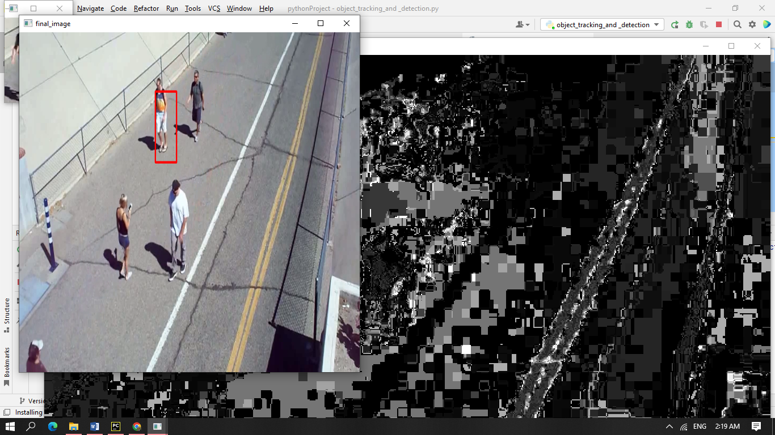

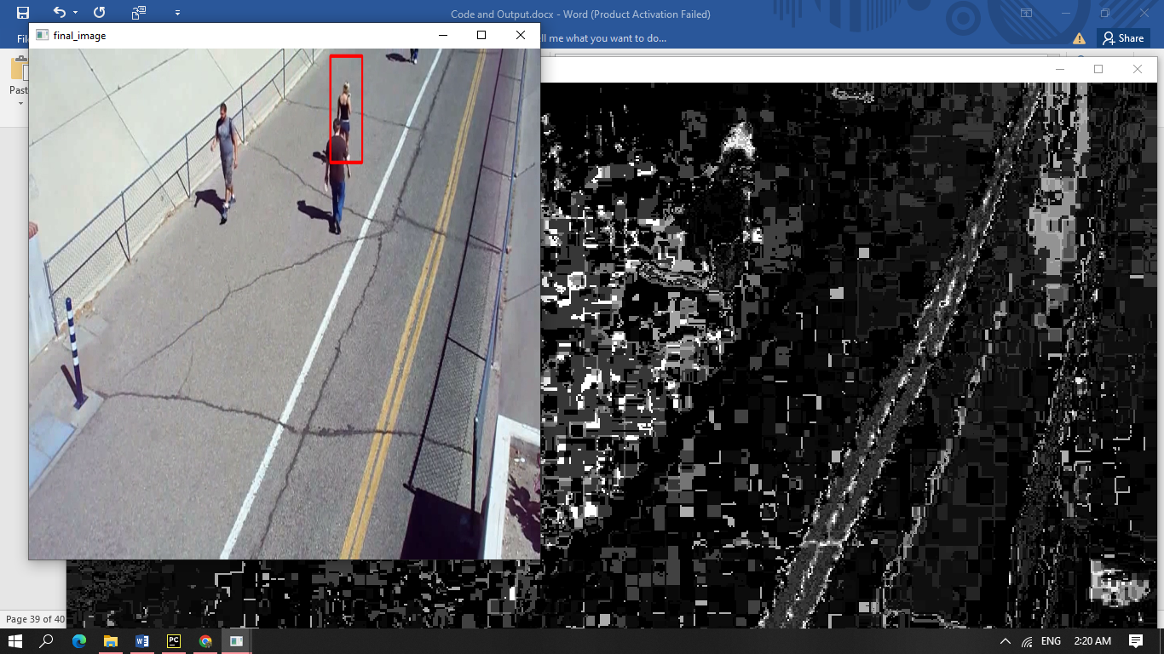

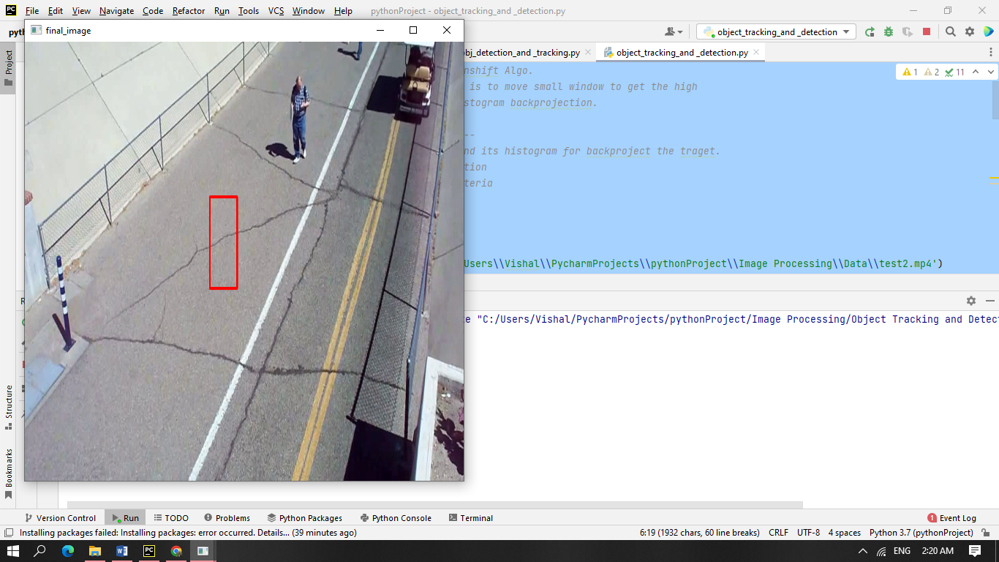

9.Cam Scanner

Scanner.py

import cv2  
import numpy as np  
import mapper  
image=cv2.imread("test_img.jpg") *#read in the image*image=cv2.resize(image,(1300,800)) *#resizing because opencv does not work well with bigger images*orig=image.copy()  
  
gray=cv2.cvtColor(image,cv2.COLOR_BGR2GRAY) *#RGB To Gray Scale*cv2.imshow("Gray Scale",gray)  
  
blurred=cv2.GaussianBlur(gray,(5,5),0) *#(5,5) is the kernel size and 0 is sigma that determines the amount of blur*cv2.imshow("Blur",blurred)  
  
edged=cv2.Canny(blurred,30,50) *#30 MinThreshold and 50 is the MaxThreshold*cv2.imshow("Canny",edged)  
  
  
contours,hierarchy=cv2.findContours(edged,cv2.RETR_LIST,cv2.CHAIN_APPROX_SIMPLE) *#retrieve the contours as a list, with simple approximation model*contours=sorted(contours,key=cv2.contourArea,reverse=True)  
  
*#the loop extracts the boundary contours of the page*for c in contours:  
 p=cv2.arcLength(c,True)  
 approx=cv2.approxPolyDP(c,0.02*p,True)  
  
 if len(approx)==4:  
 target=approx  
 break  
approx=mapper.mapp(target) *#find endpoints of the sheet*pts=np.float32([[0,0],[800,0],[800,800],[0,800]]) *#map to 800*800 target window*op=cv2.getPerspectiveTransform(approx,pts) *#get the top or bird eye view effect*dst=cv2.warpPerspective(orig,op,(800,800))

cv2.imshow("Scanned",dst)  
*# press q or Esc to close*cv2.waitKey(0)  
cv2.destroyAllWindows()  
  
   
mapper.py

import numpy as np  
  
def mapp(h):  
 h = h.reshape((4,2))  
 hnew = np.zeros((4,2),dtype = np.float32)  
  
 add = h.sum(1)  
 hnew[0] = h[np.argmin(add)]  
 hnew[2] = h[np.argmax(add)]  
  
 diff = np.diff(h,axis = 1)  
 hnew[1] = h[np.argmin(diff)]  
 hnew[3] = h[np.argmax(diff)]  
  
 return hnew

Original Image

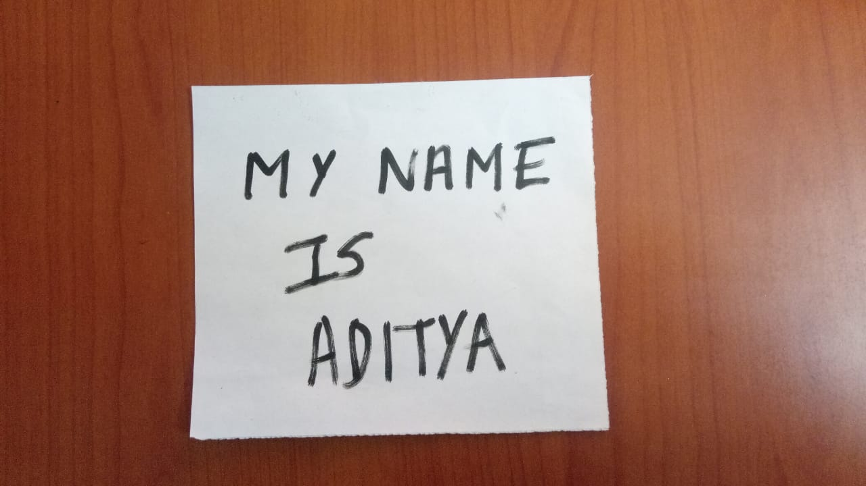

**Output after running the Python Code for Scanner.py**First we get the gray scale image entitled “Gray Scale” as output.

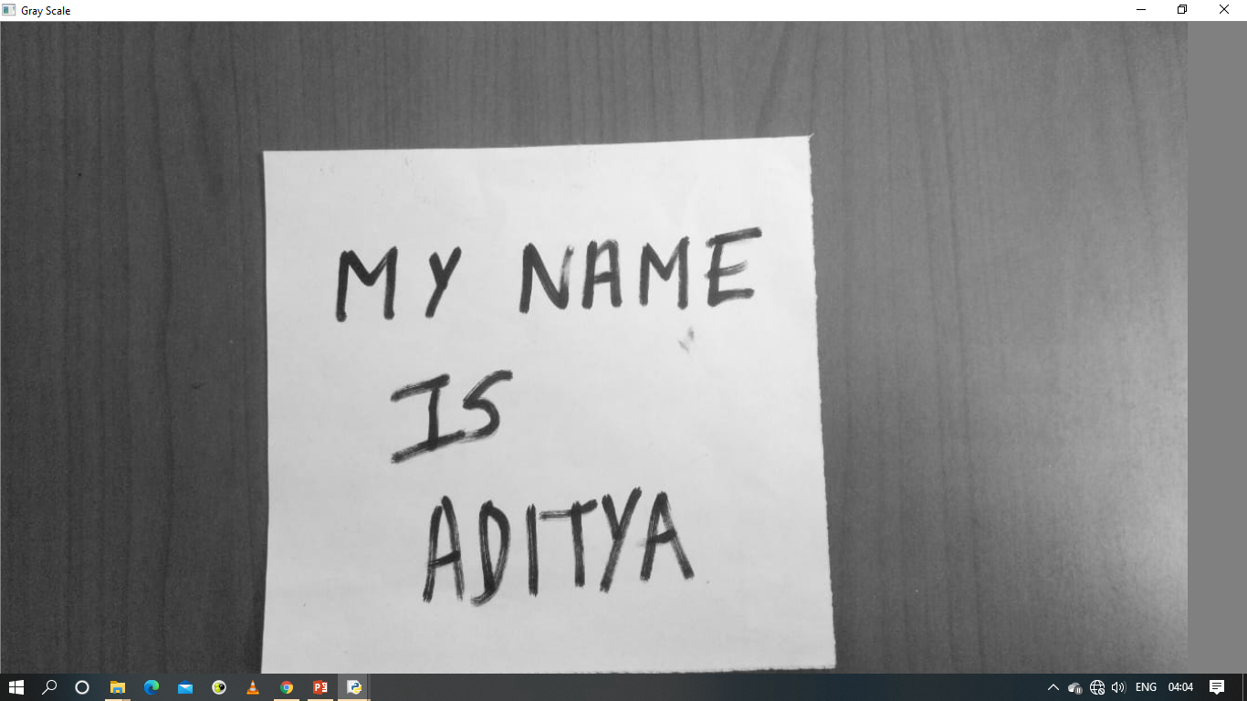

Secondly we get the Blurred Image entitled “Blur”.

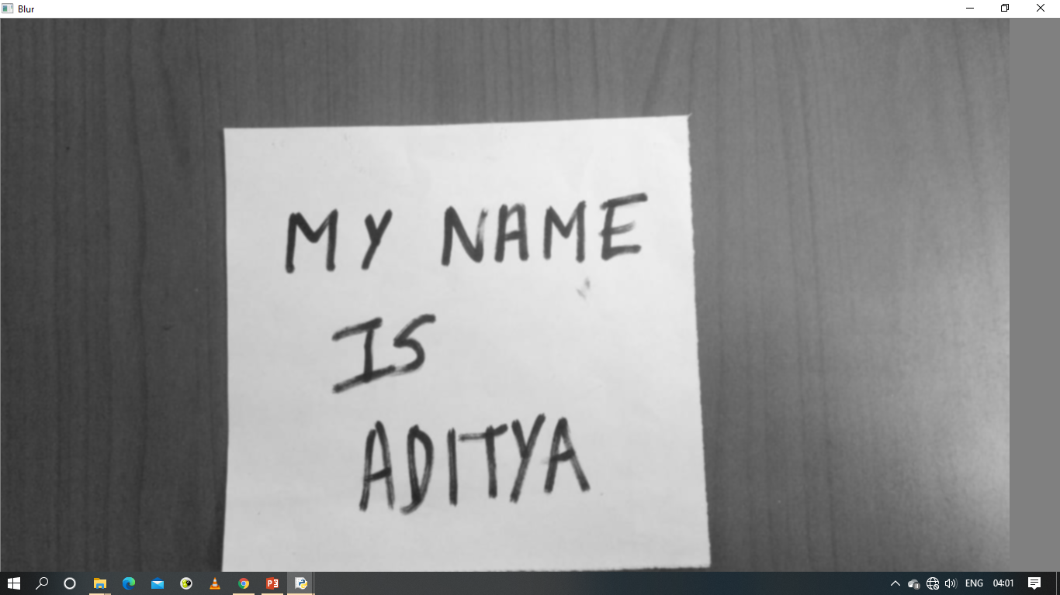

Thirdly we get the Canny Detected Image entitled “Canny”.

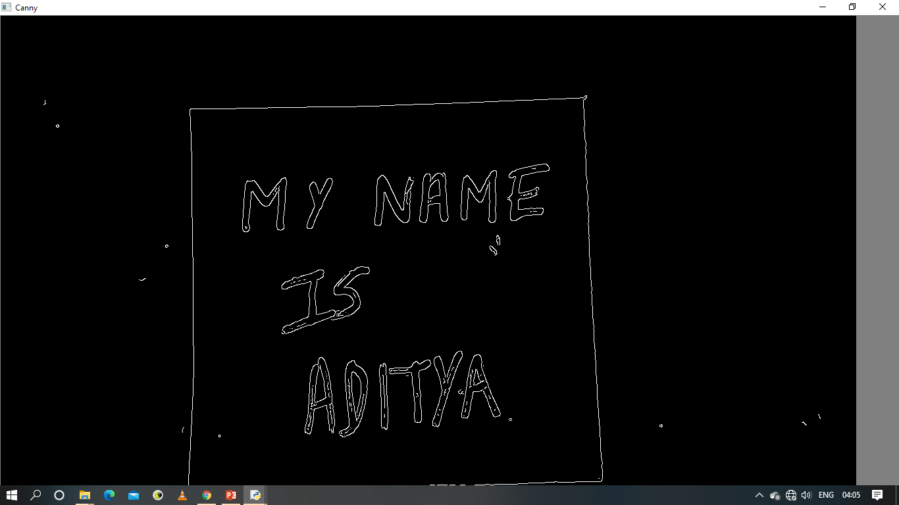

Fourthly we get the Scanned Image entitled “Scanned” which is the final output.

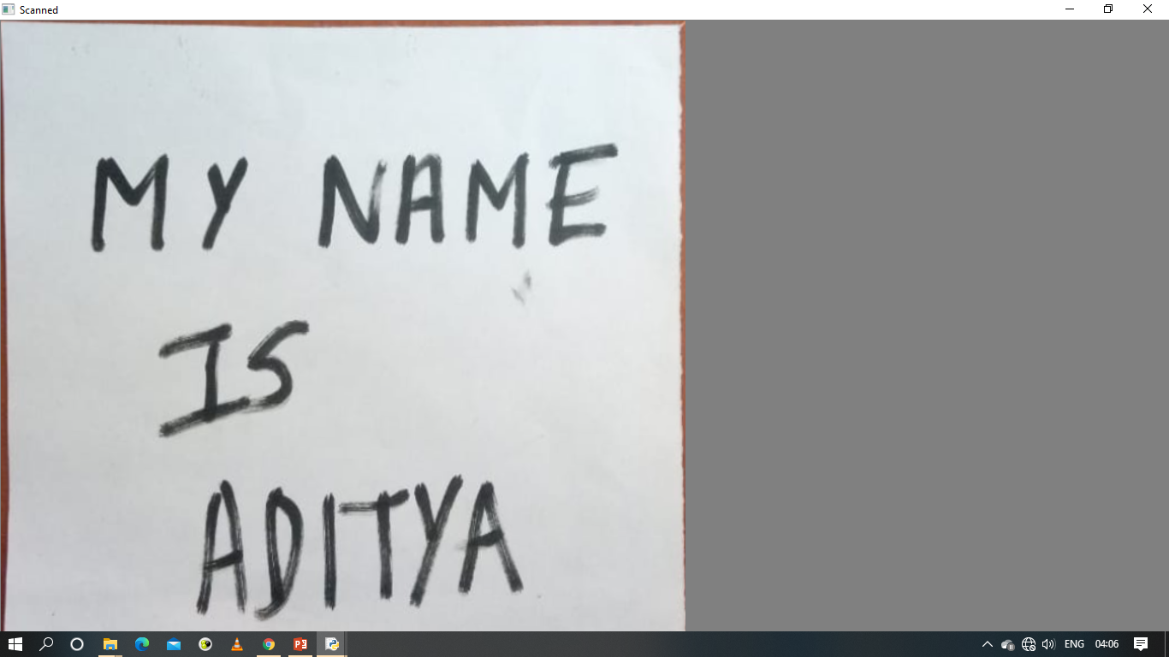

10.Screen Recorder

screen_recorder.py

*#Screen Recorder without WebCam*import datetime  
from PIL import ImageGrab  
import numpy as np  
import cv2  
from win32api import GetSystemMetrics  
  
width = GetSystemMetrics(0)  
height = GetSystemMetrics(1)  
time_stamp = datetime.datetime.now().strftime('%Y-%m-%d %H-%M-%S')  
file_name = f'{time_stamp}.mp4'  
fourcc = cv2.VideoWriter_fourcc('m', 'p', '4', 'v')  
captured_video = cv2.VideoWriter(file_name, fourcc, 20.0, (width, height))  
  
  
while True:  
 img = ImageGrab.grab(bbox=(0, 0, width, height))  
 img_np = np.array(img)  
 img_final = cv2.cvtColor(img_np, cv2.COLOR_BGR2RGB)  
 cv2.imshow('Secret Capture', img_final)  
  
 captured_video.write(img_final)  
 if cv2.waitKey(10) == ord('q'):  
 break

Output

Screen Recorder without WebCam

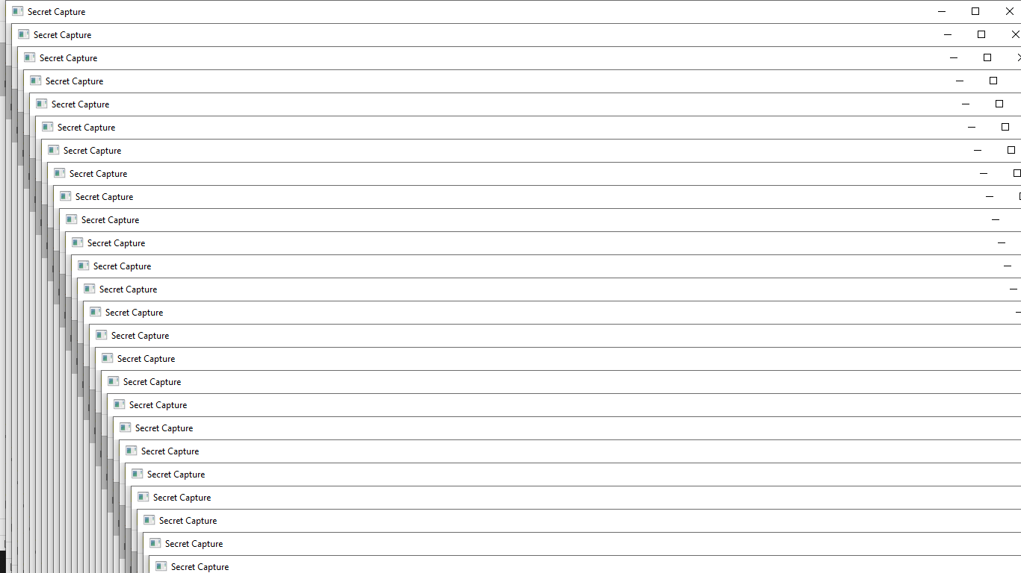

Screen Recorder saved the video file with time stamp in .mp4 format

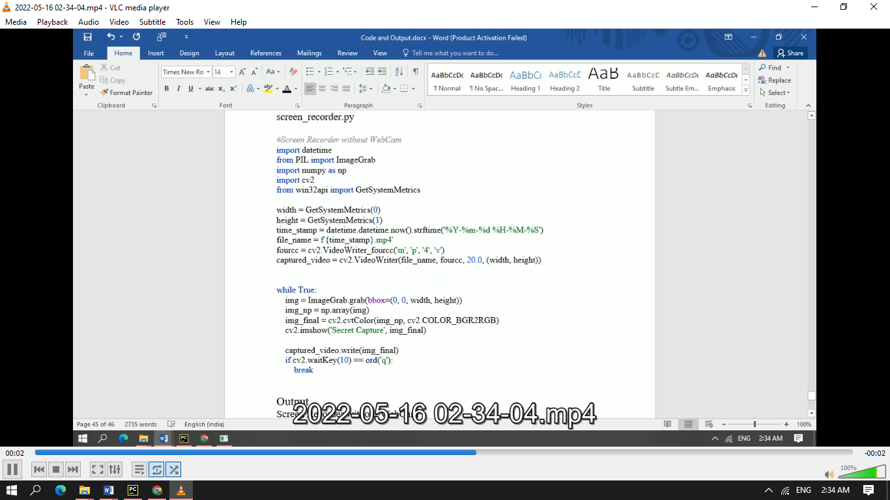

screenrecorderwithwebcam.py

*#Screen Recorder With WebCam*import datetime  
from PIL import ImageGrab  
import numpy as np  
import cv2  
from win32api import GetSystemMetrics  
  
width = GetSystemMetrics(0)  
height = GetSystemMetrics(1)  
time_stamp = datetime.datetime.now().strftime('%Y-%m-%d %H-%M-%S')  
file_name = f'{time_stamp}.mp4'  
fourcc = cv2.VideoWriter_fourcc('m', 'p', '4', 'v')  
captured_video = cv2.VideoWriter(file_name, fourcc, 20.0, (width, height))  
  
webcam = cv2.VideoCapture(0)  
  
while True:  
 img = ImageGrab.grab(bbox=(0, 0, width, height))  
 img_np = np.array(img)  
 img_final = cv2.cvtColor(img_np, cv2.COLOR_BGR2RGB)  
 _, frame = webcam.read()  
 fr_height, fr_width, _ = frame.shape  
 img_final[0:fr_height, 0: fr_width, :] = frame[0: fr_height, 0: fr_width, :]  
 cv2.imshow('Secret Capture', img_final)  
 *# cv2.imshow('webcam', frame)* captured_video.write(img_final)  
 if cv2.waitKey(10) == ord('q'):  
 break

Output

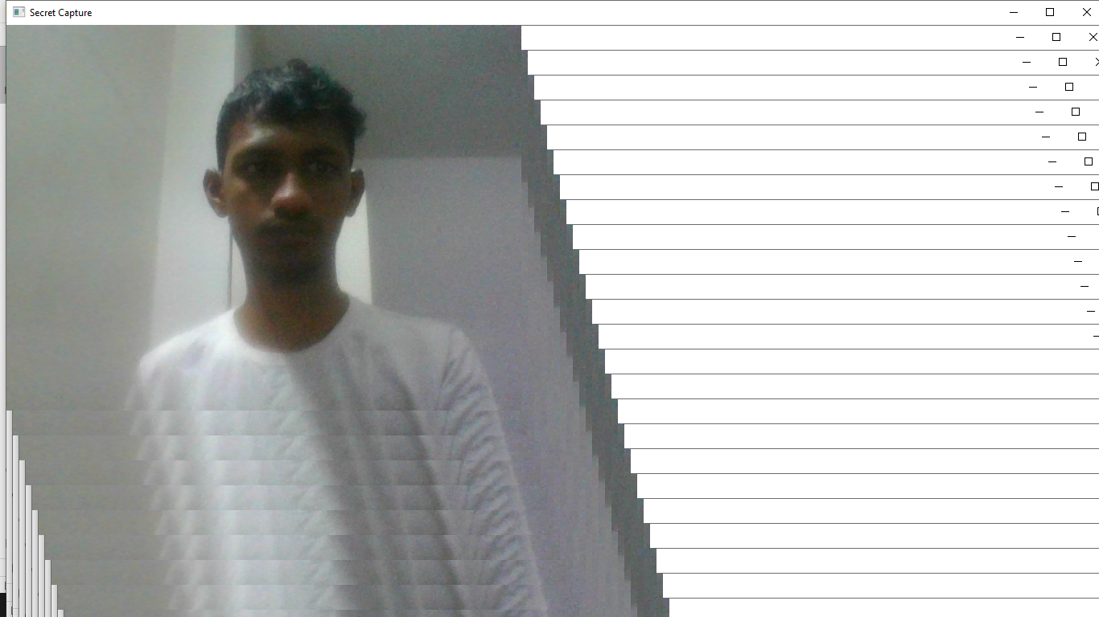

Screen Recorder saved the video file with time stamp in .mp4 format

